**MAVEN JAVA PROJECT**

**1.Creating a new maven java project in eclipse :** Select Project name and location ,use default workspace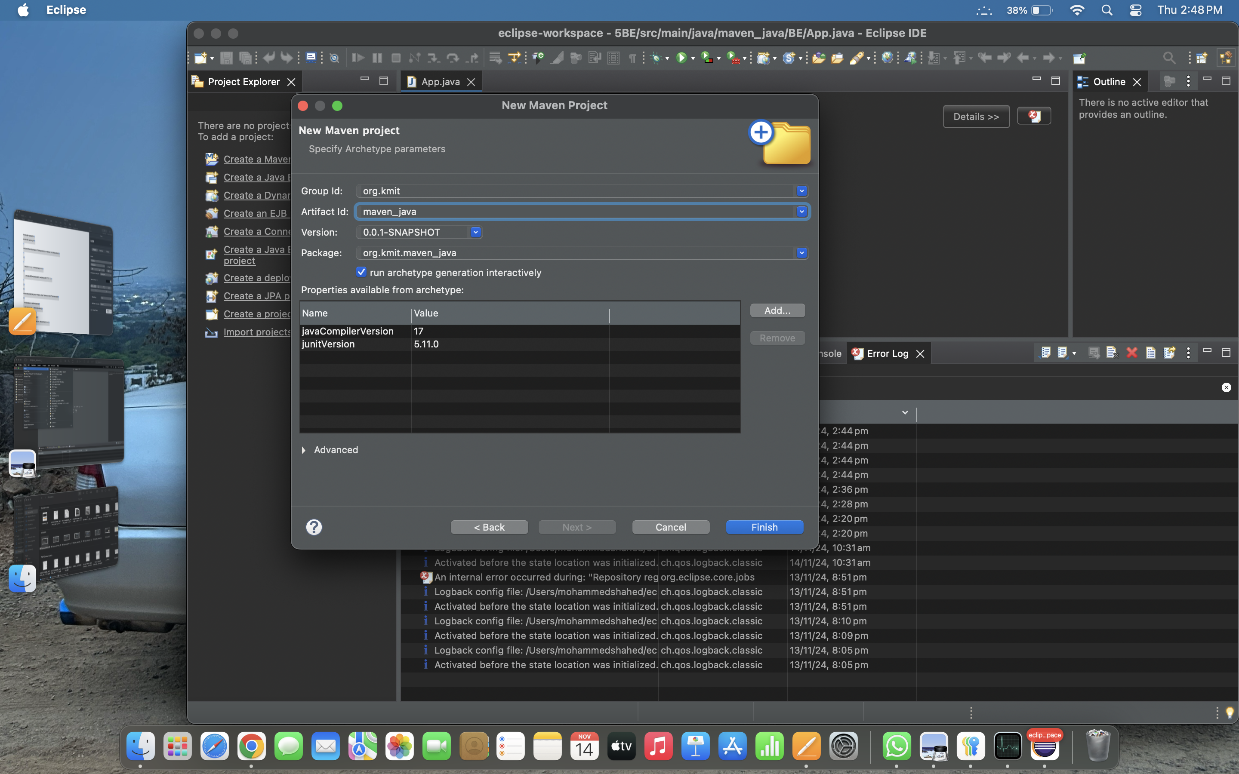

**2.Select An Archetype:** Selecting the archetype as quick start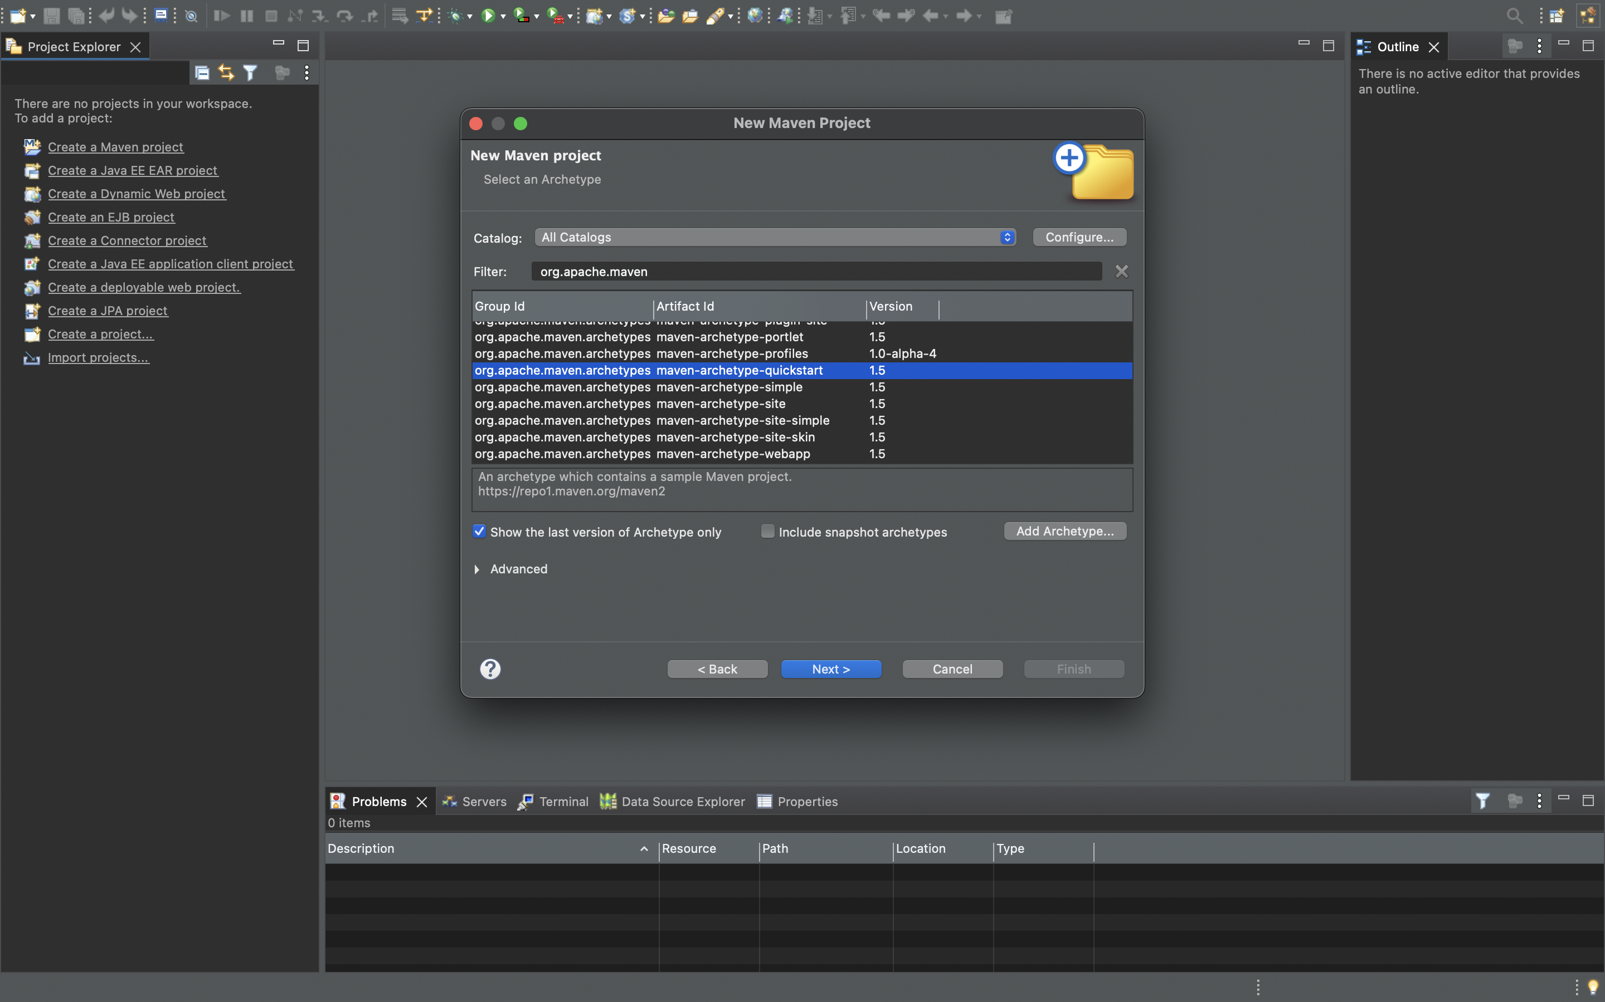

**3.Specify Archetype parameters :** Add GroupId as mavenjava.com and Artifact Id as 22bd1a05bm or else any other name for ArtifactId and finish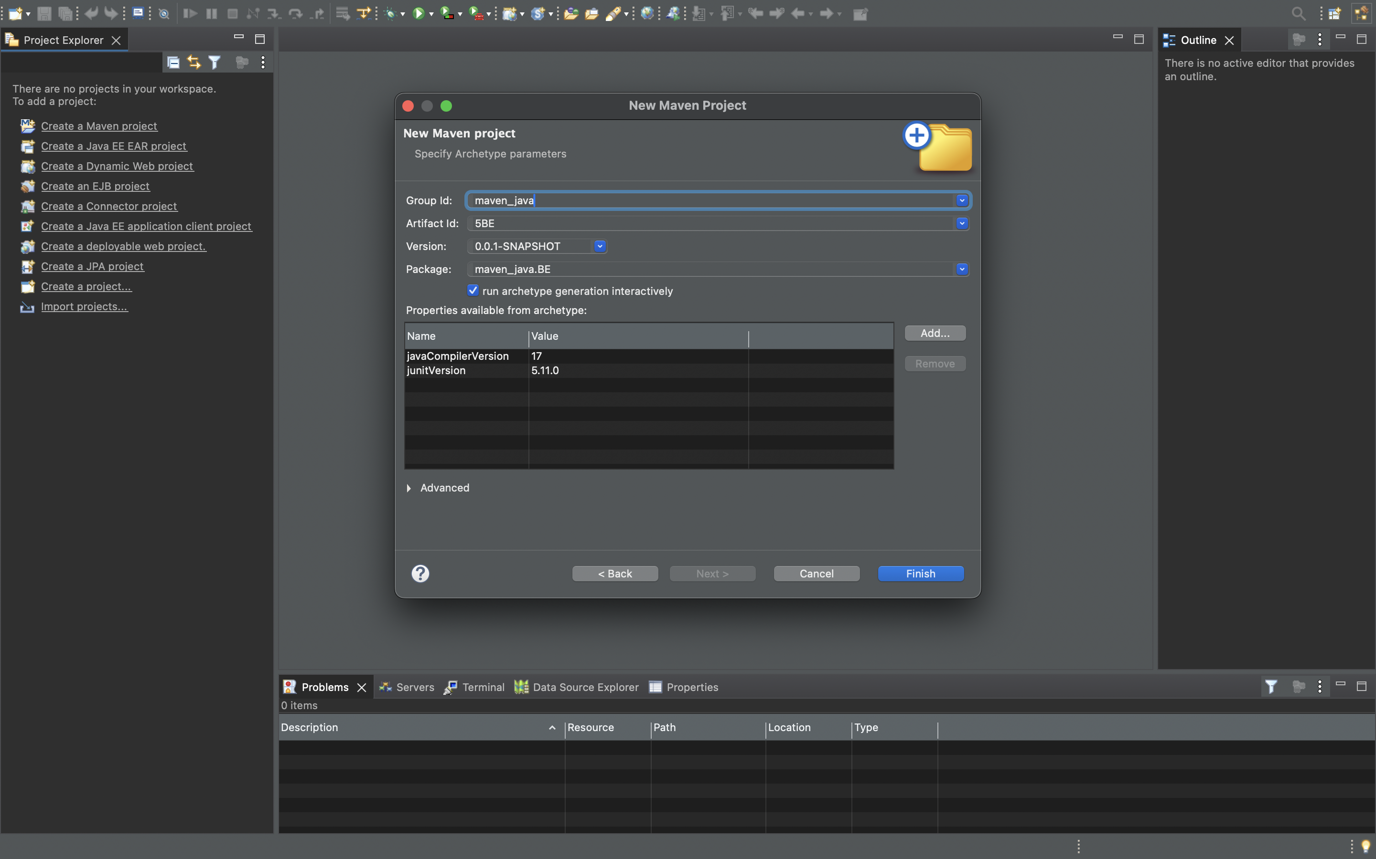

**4.Building of a new maven project is done**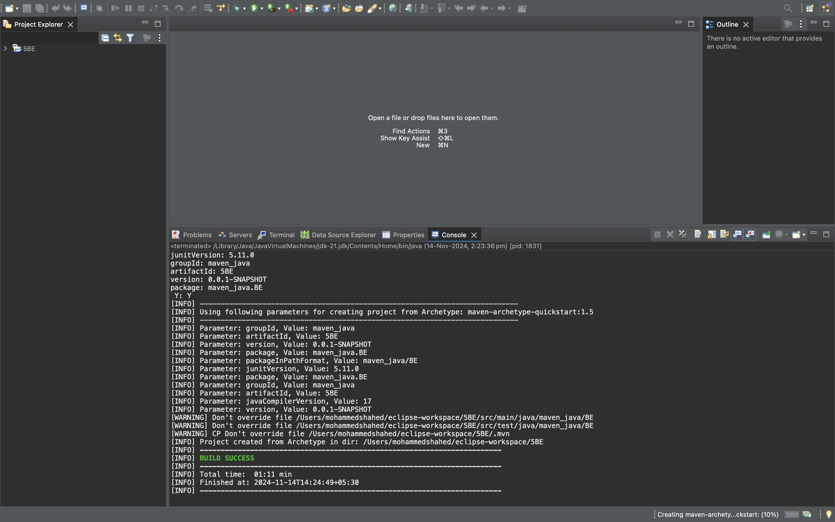

**6.Open App.java:** Open app.java file in the folder src>main>java>com>kmit>bd1a05bm>App.java and write a java code .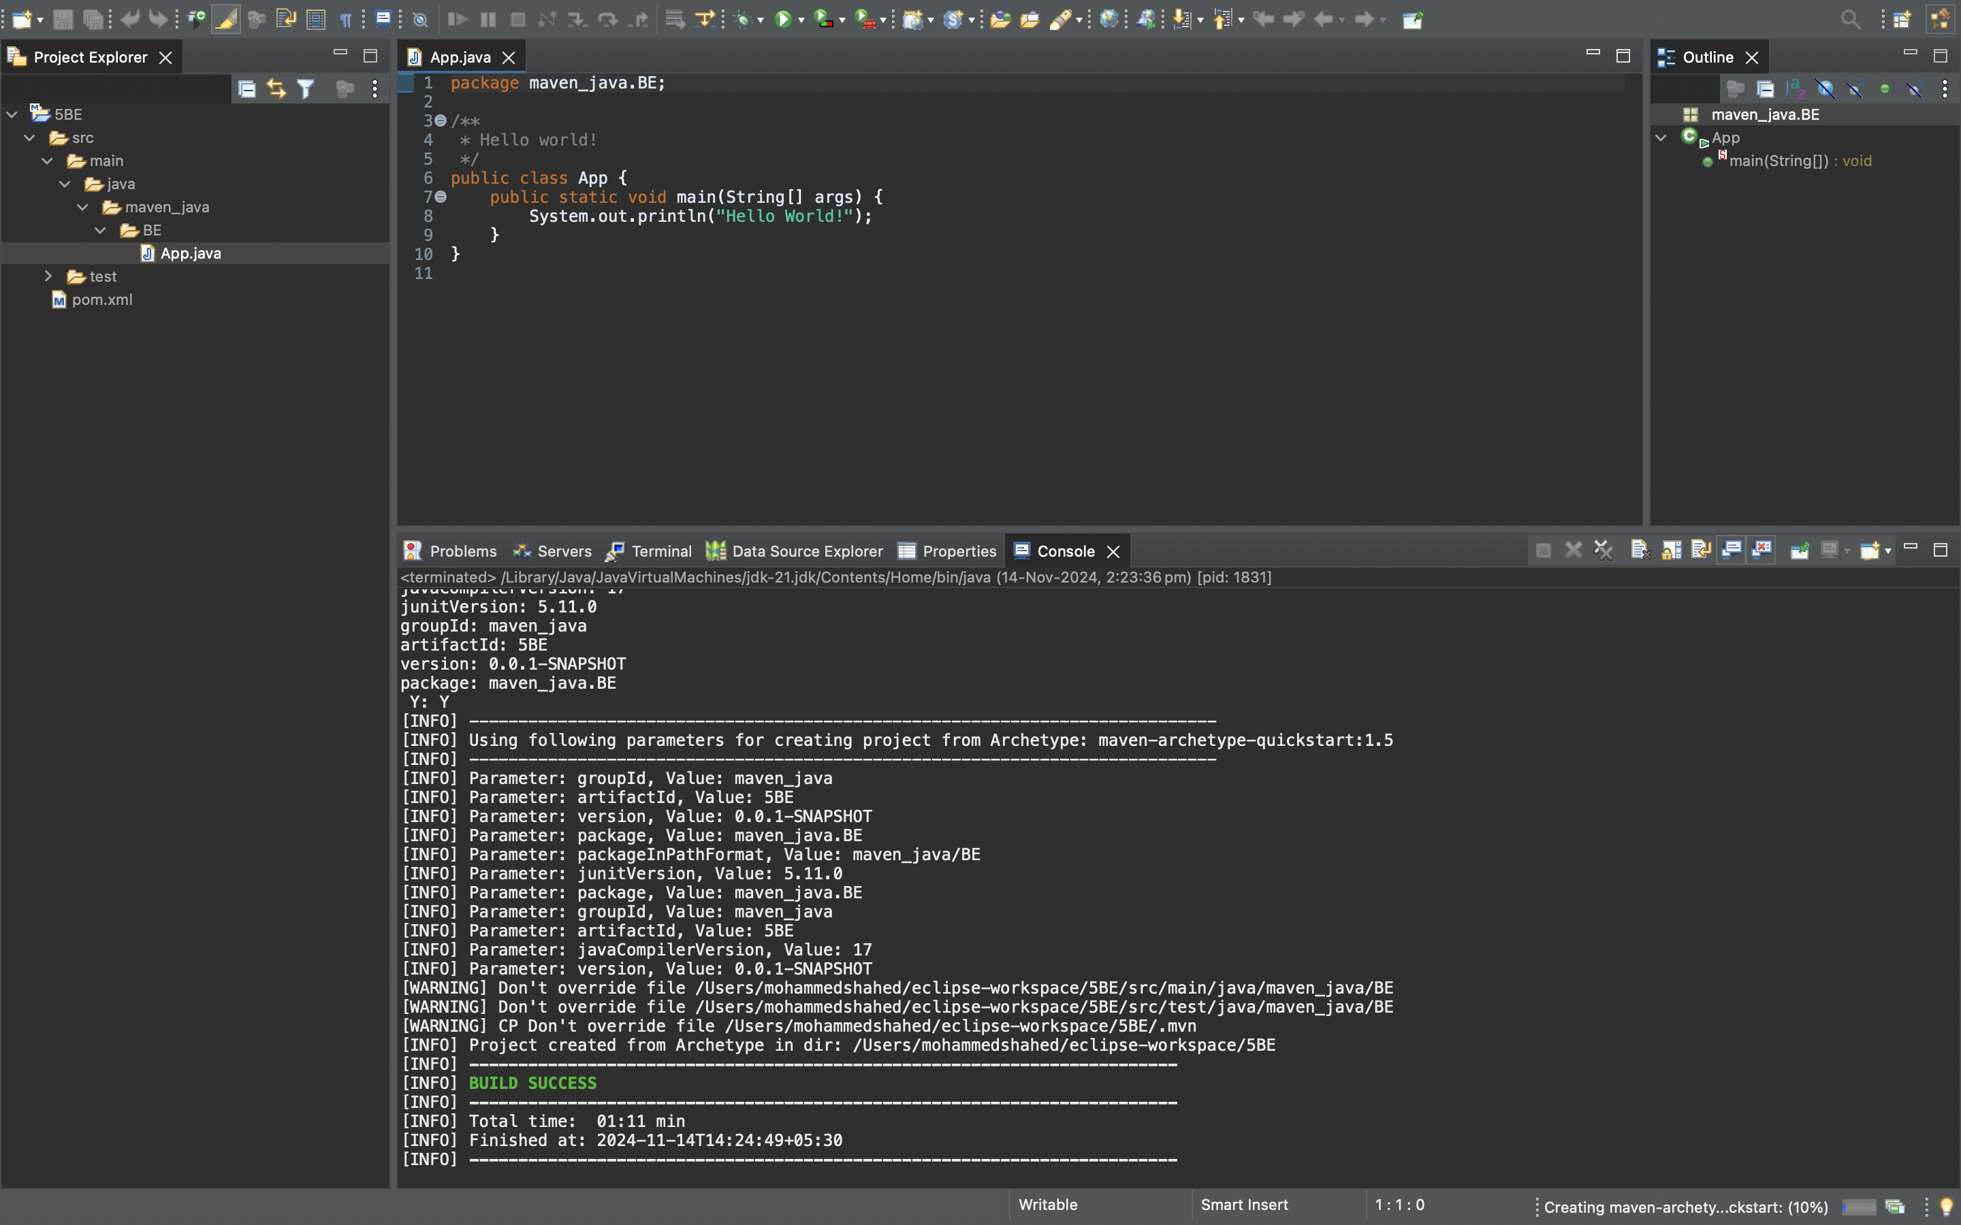

**7.Maven Clean :**Right click the maven project file and select Run as the select Maven clean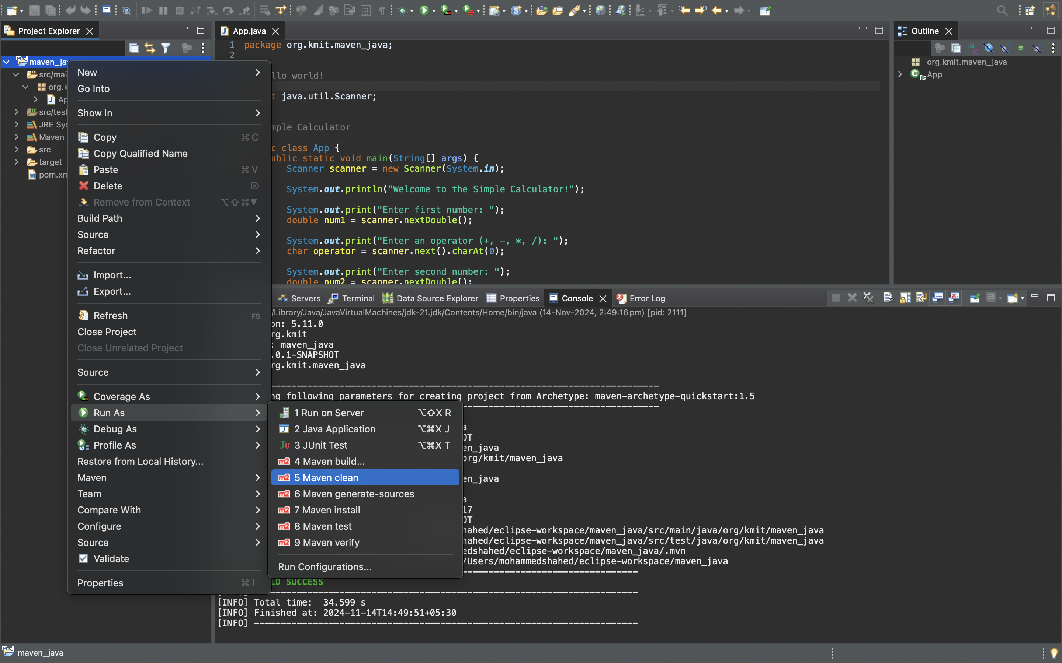

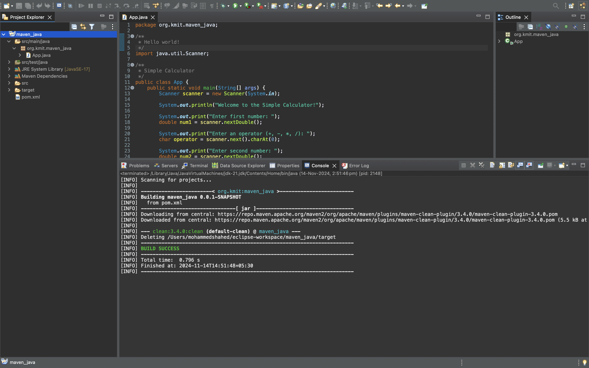**8.Maven install :** Right click the maven project file and select Run as the select Maven install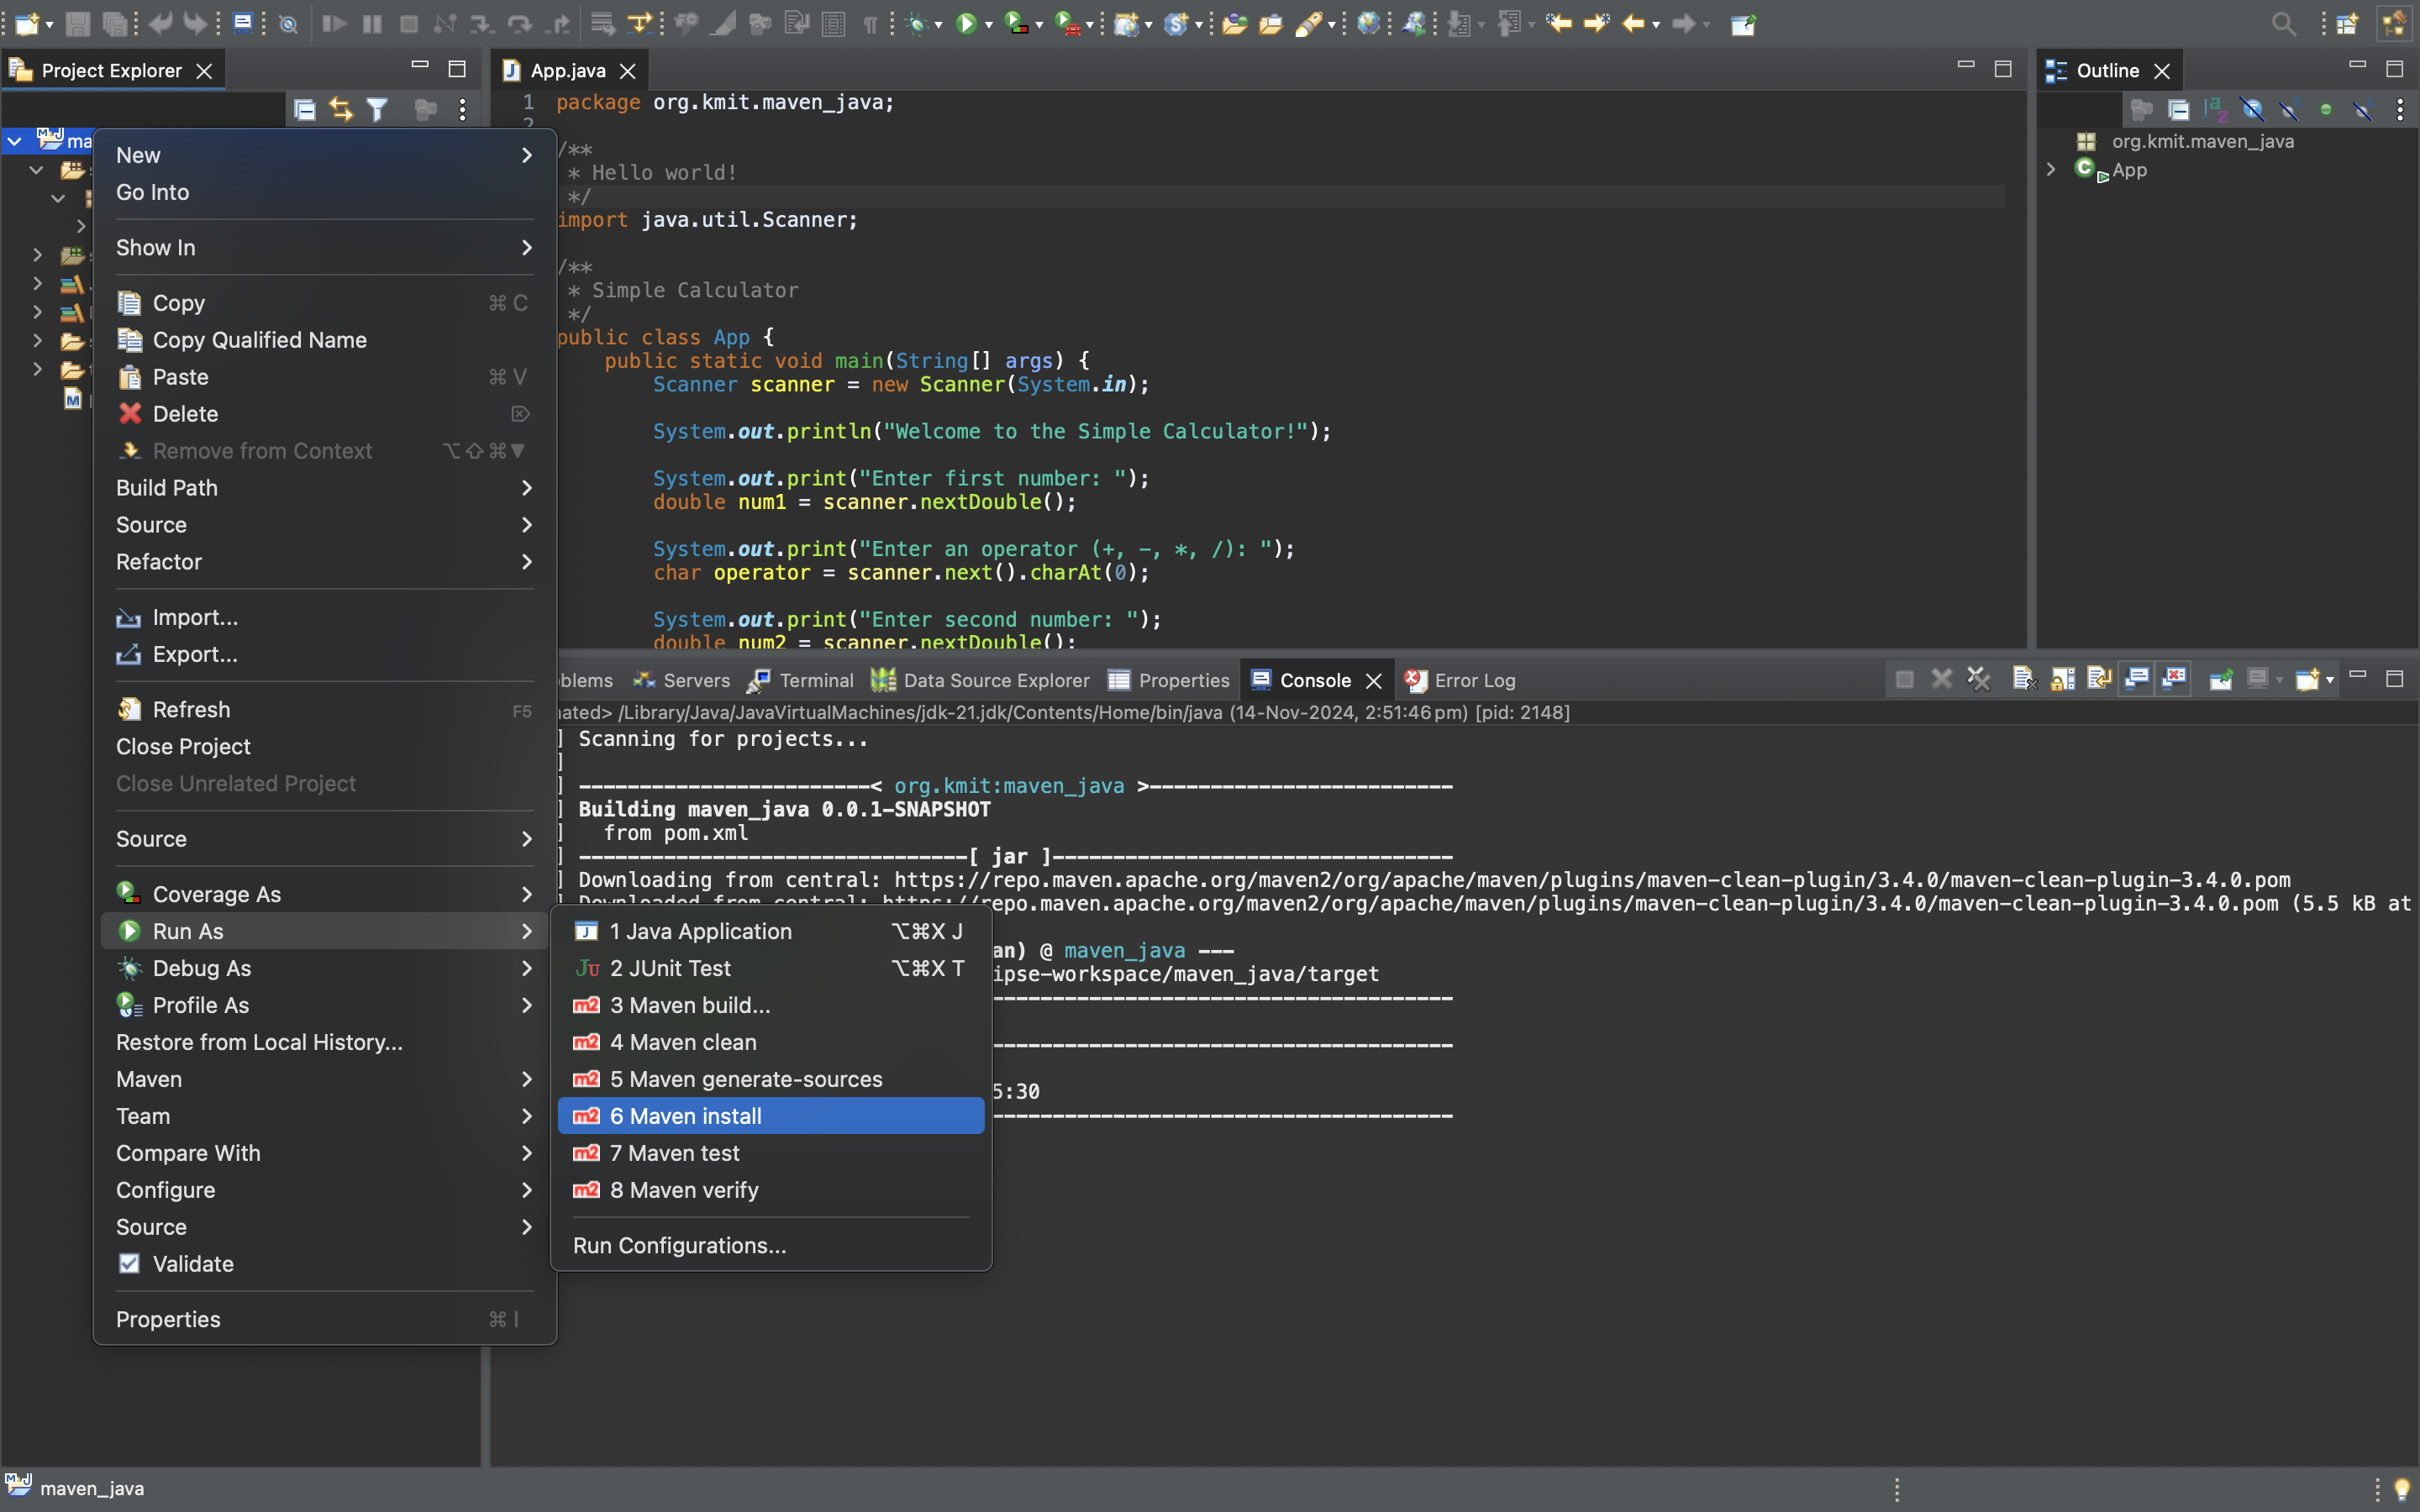

**9.Maven build :** Right click the maven project file and select Run as the select Maven build

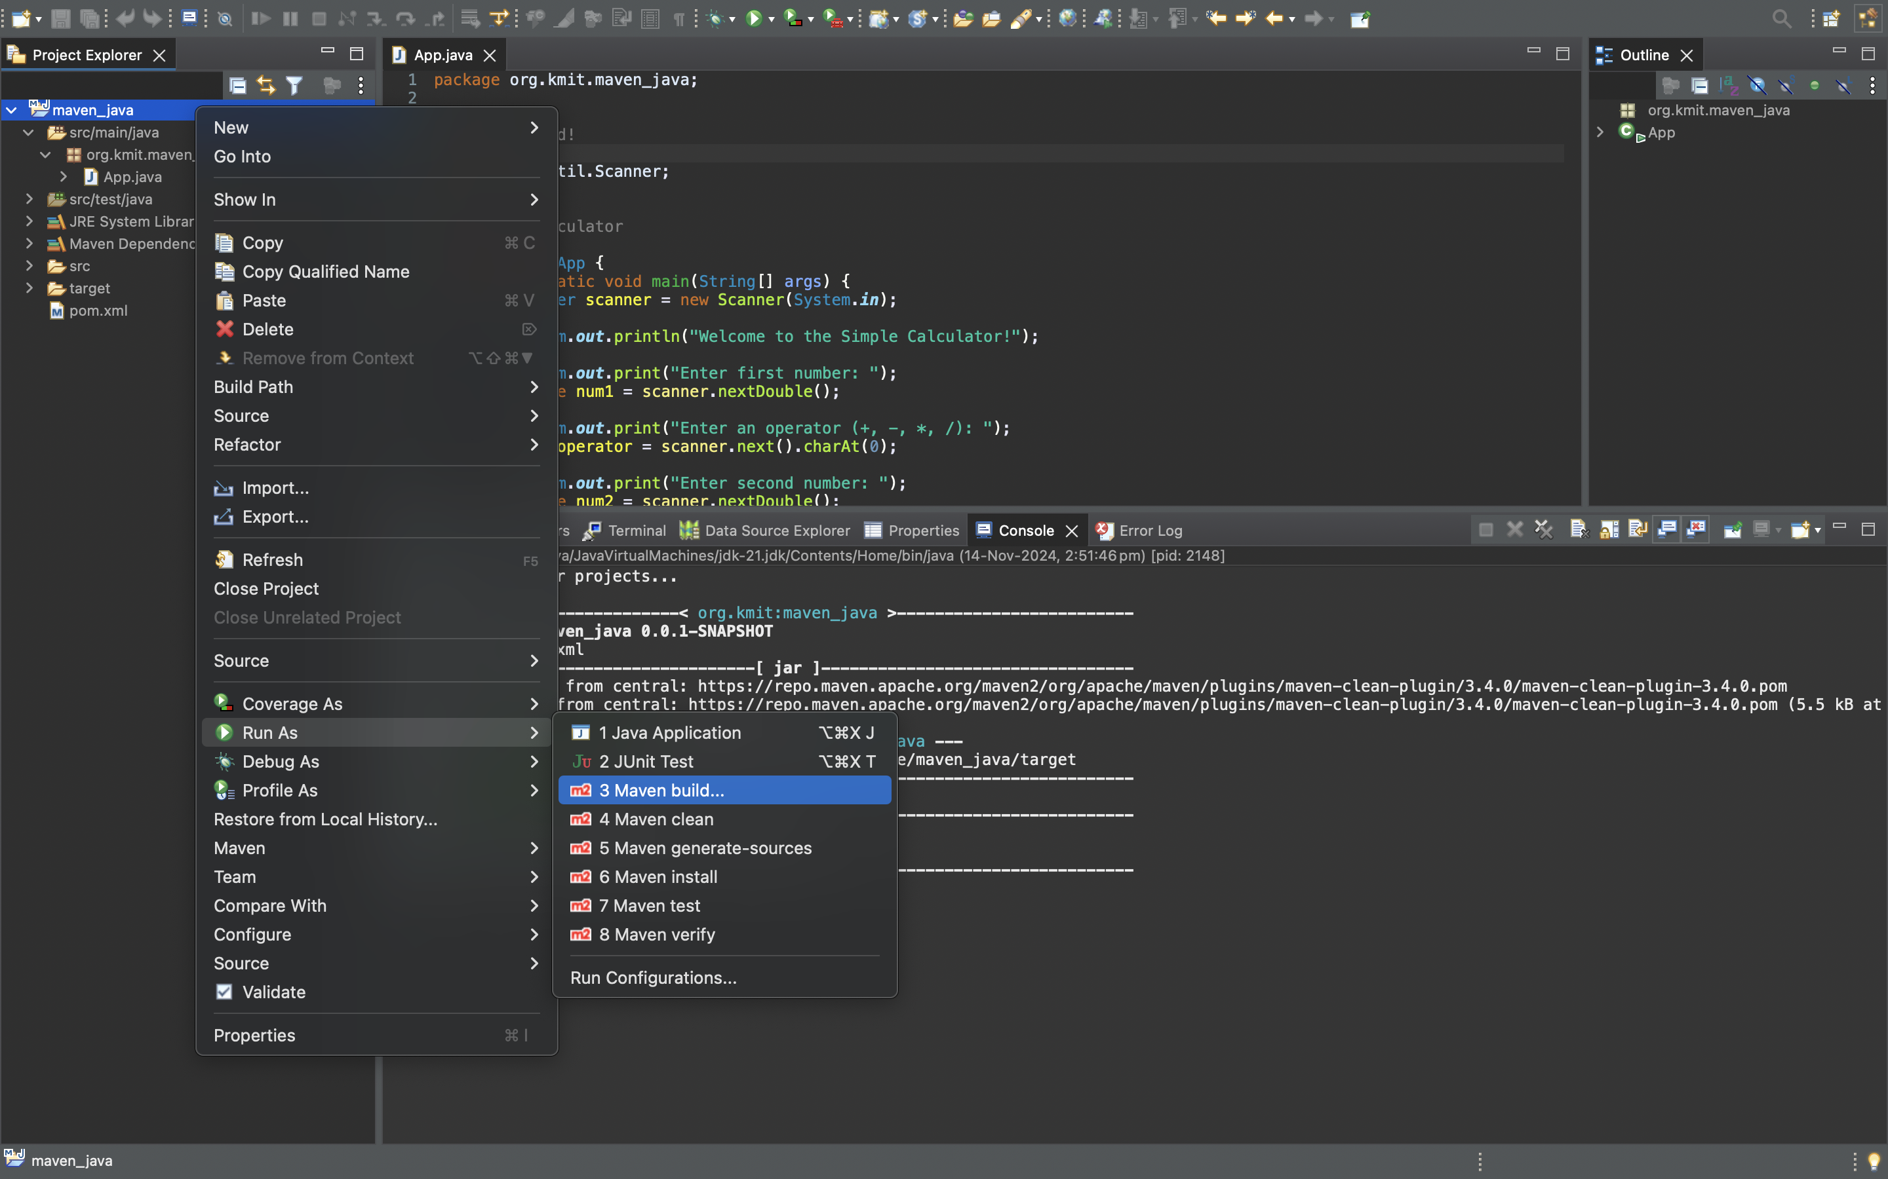

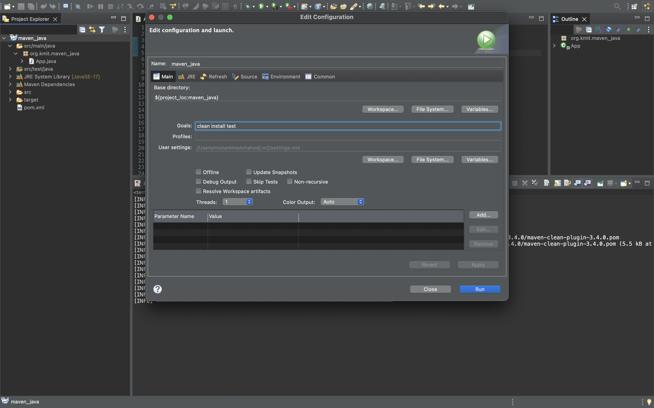

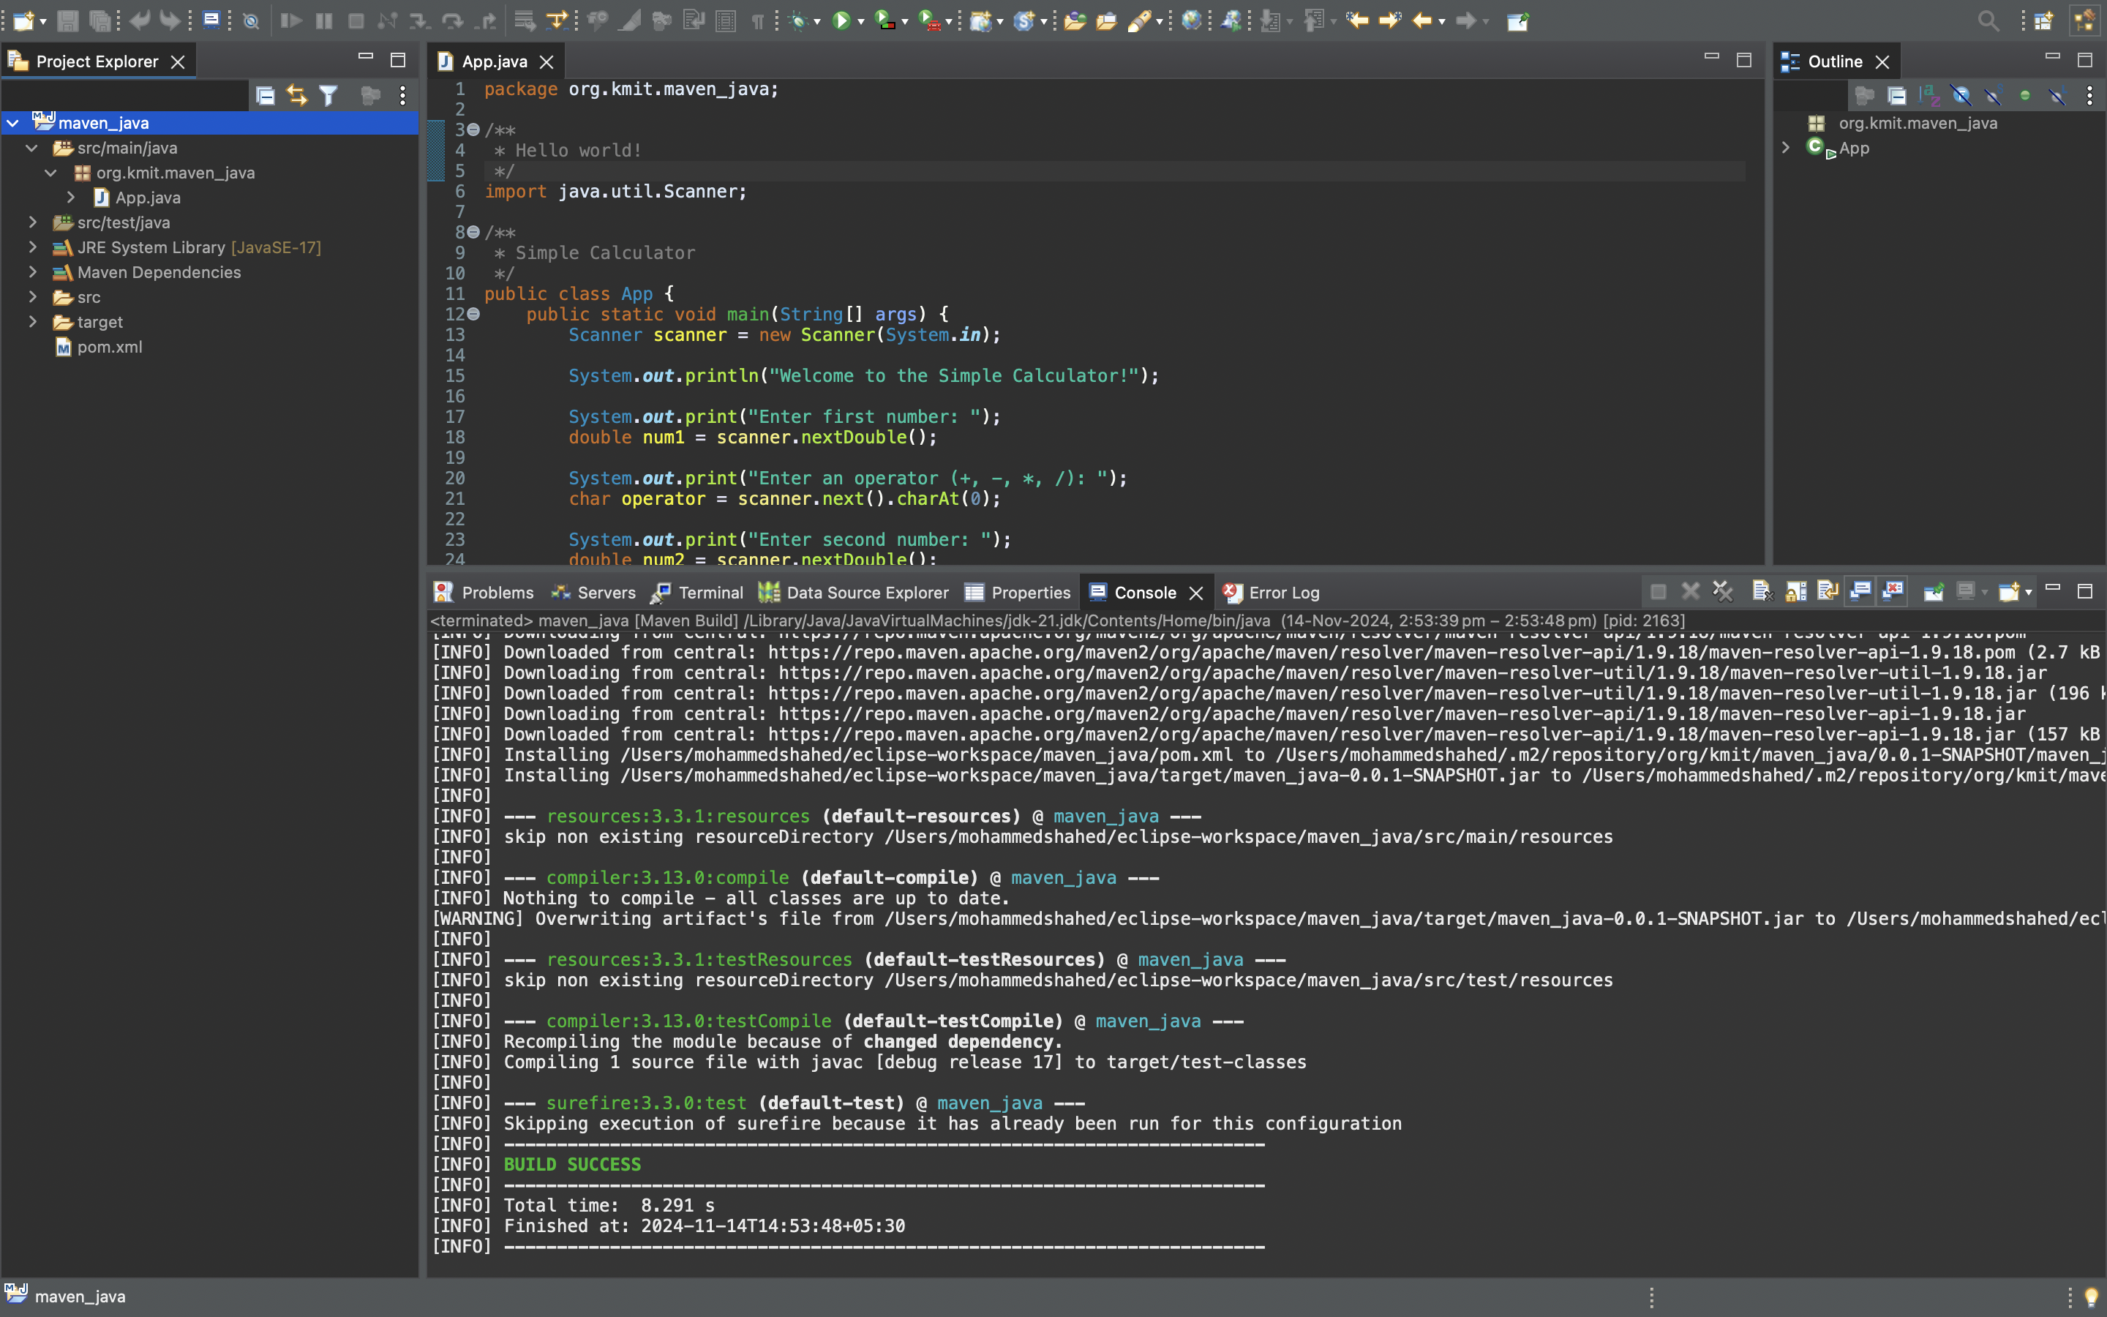

**10.Maven test :** Right click the maven project file and select Run as the select Maven test

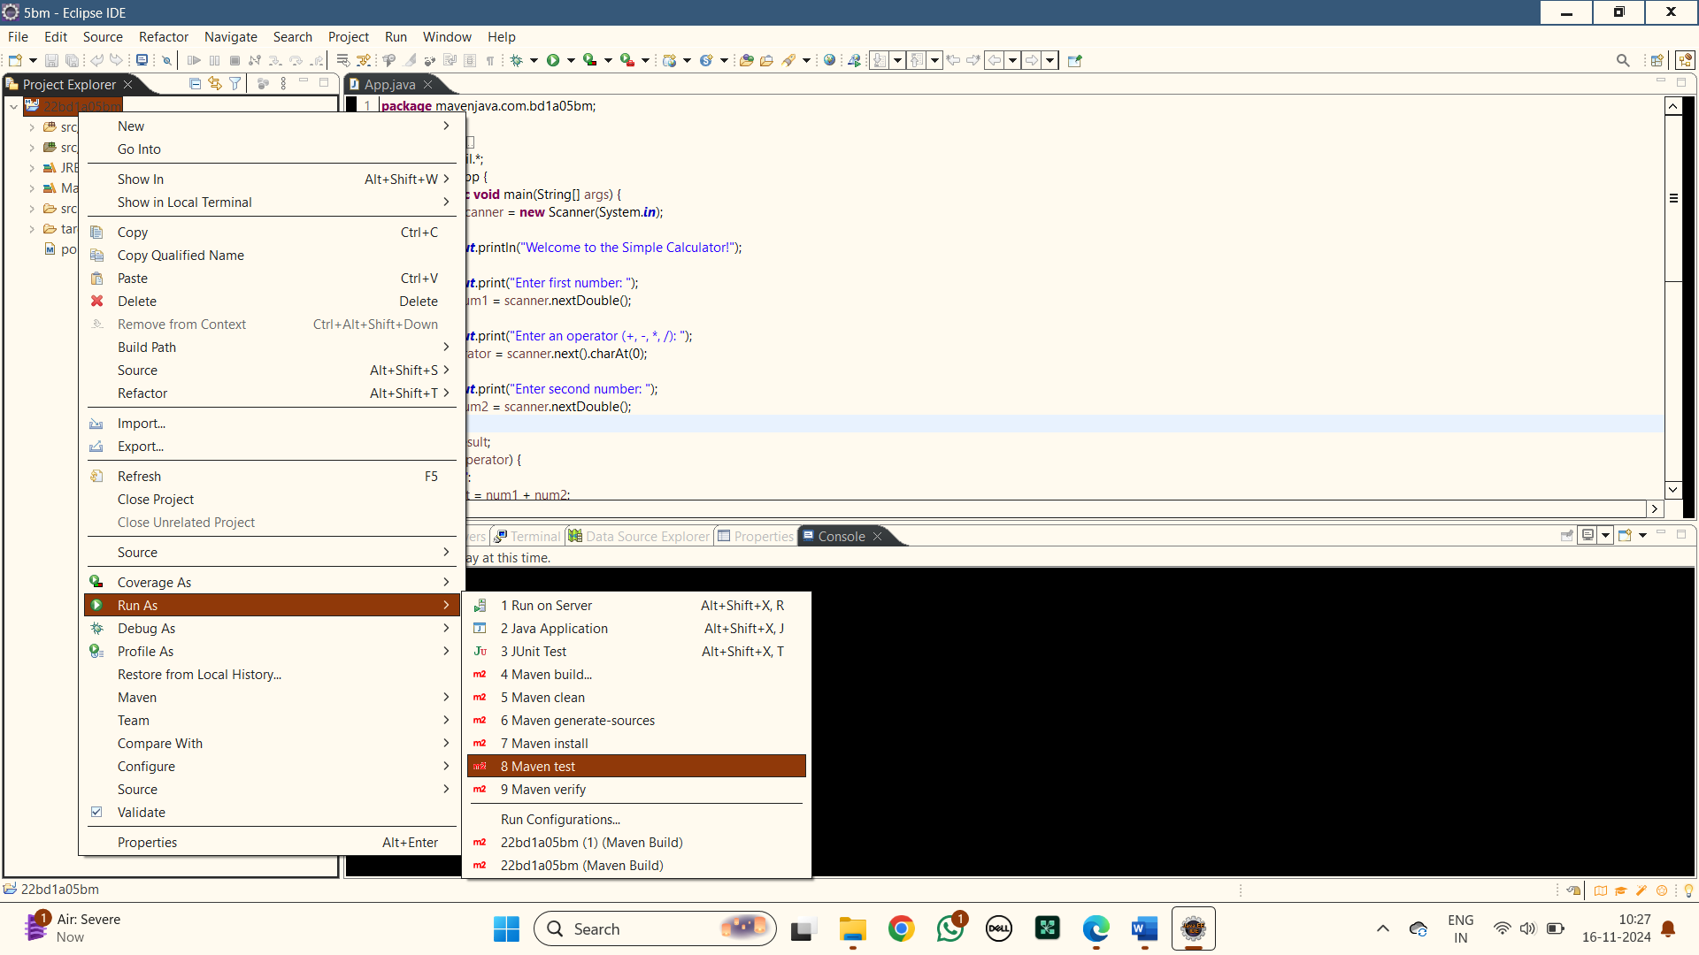

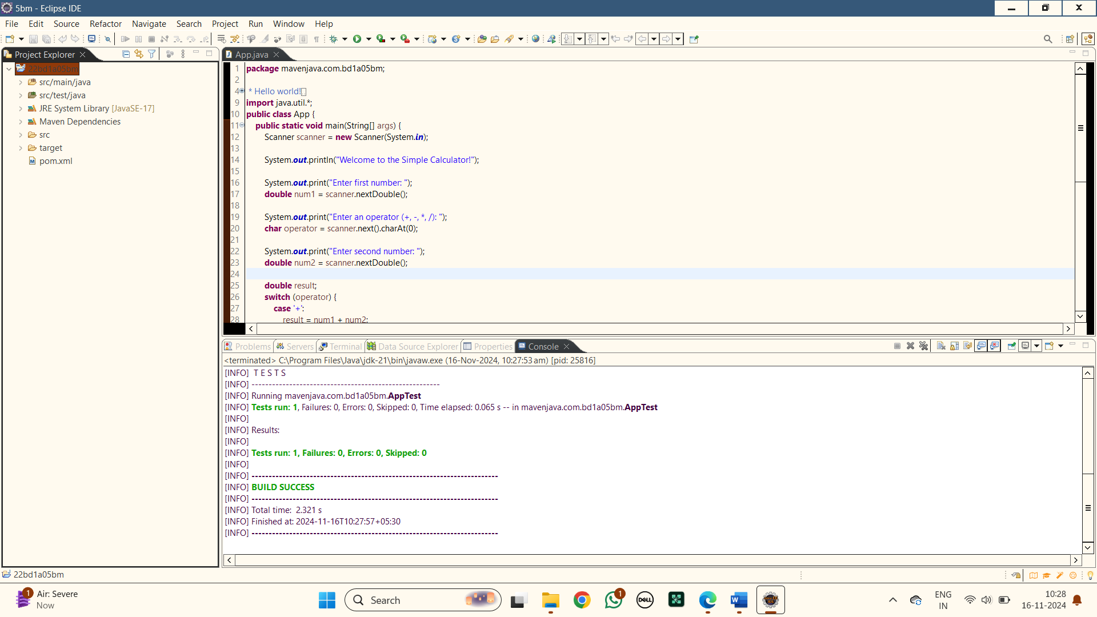

**11.Run as Java Application :** Right click the maven project file and select Run as the Java Application

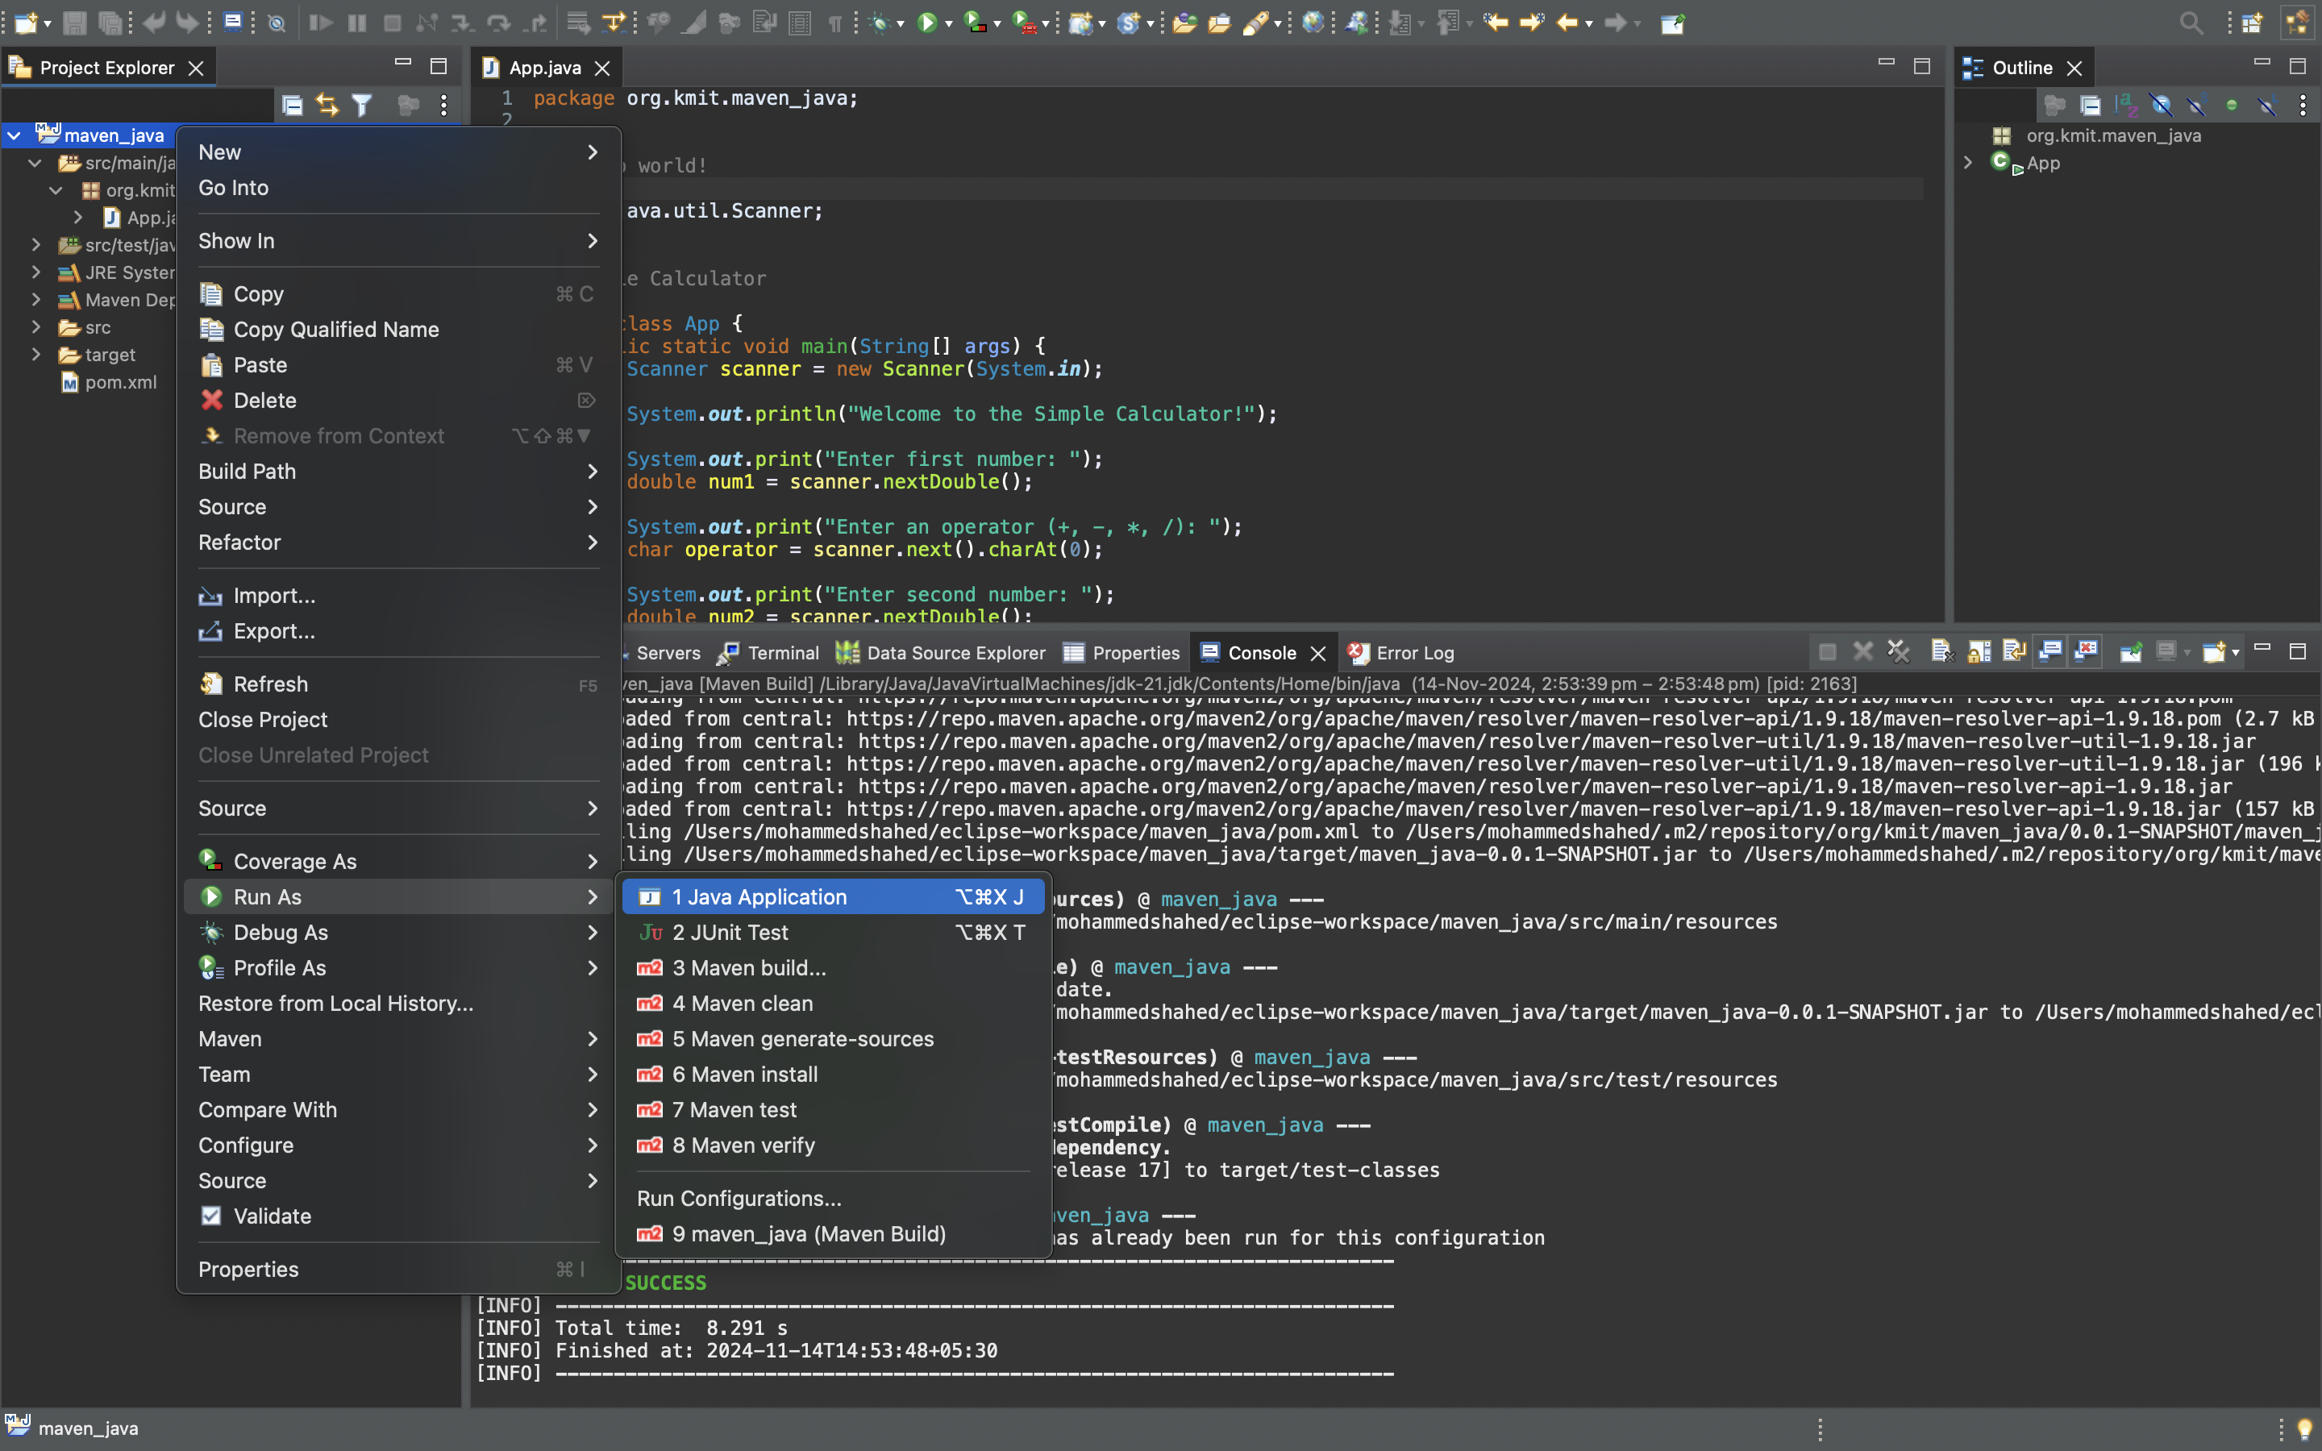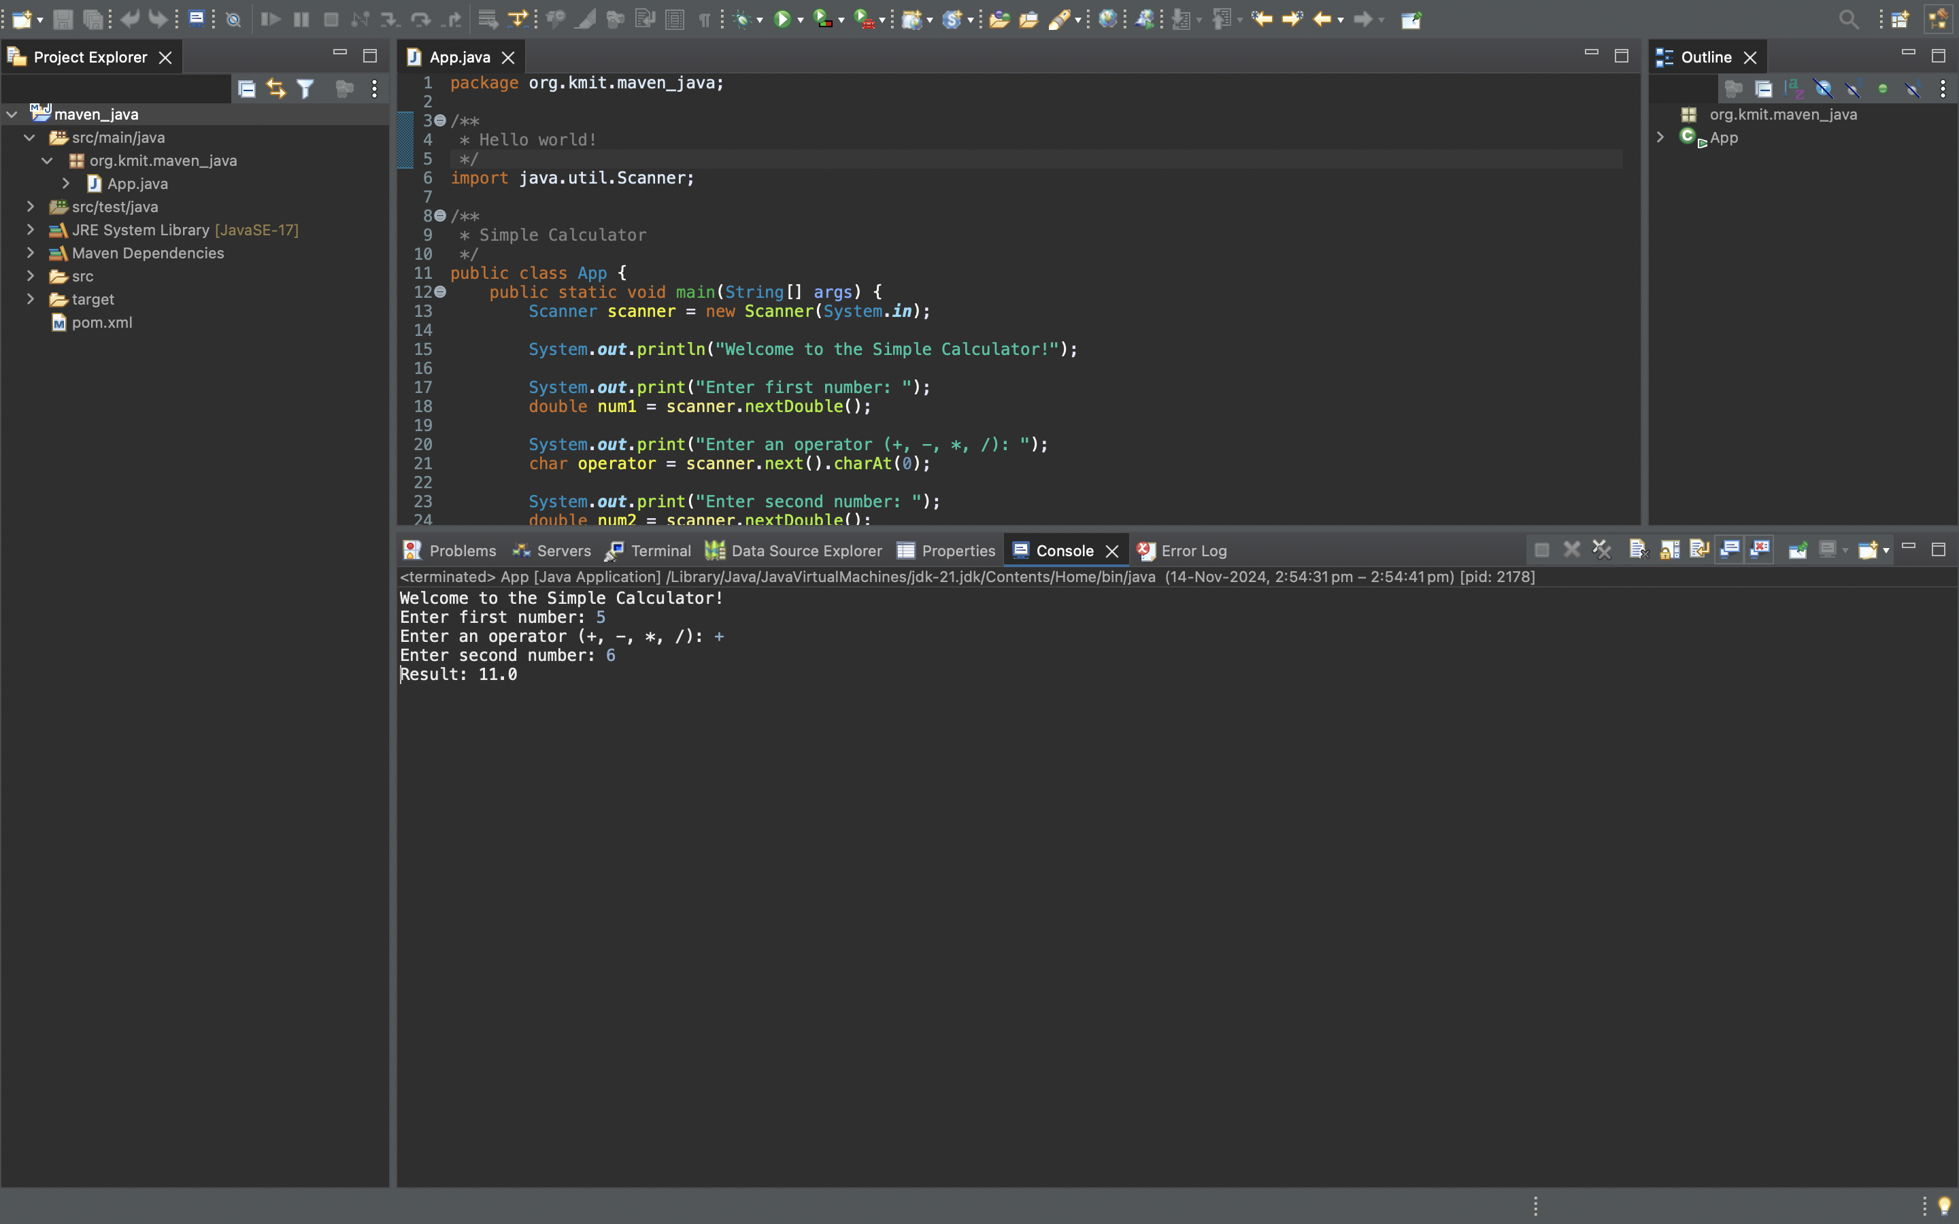

**12.Open with git bash :** Right click the maven project file and select show in local terminal and then select Git bash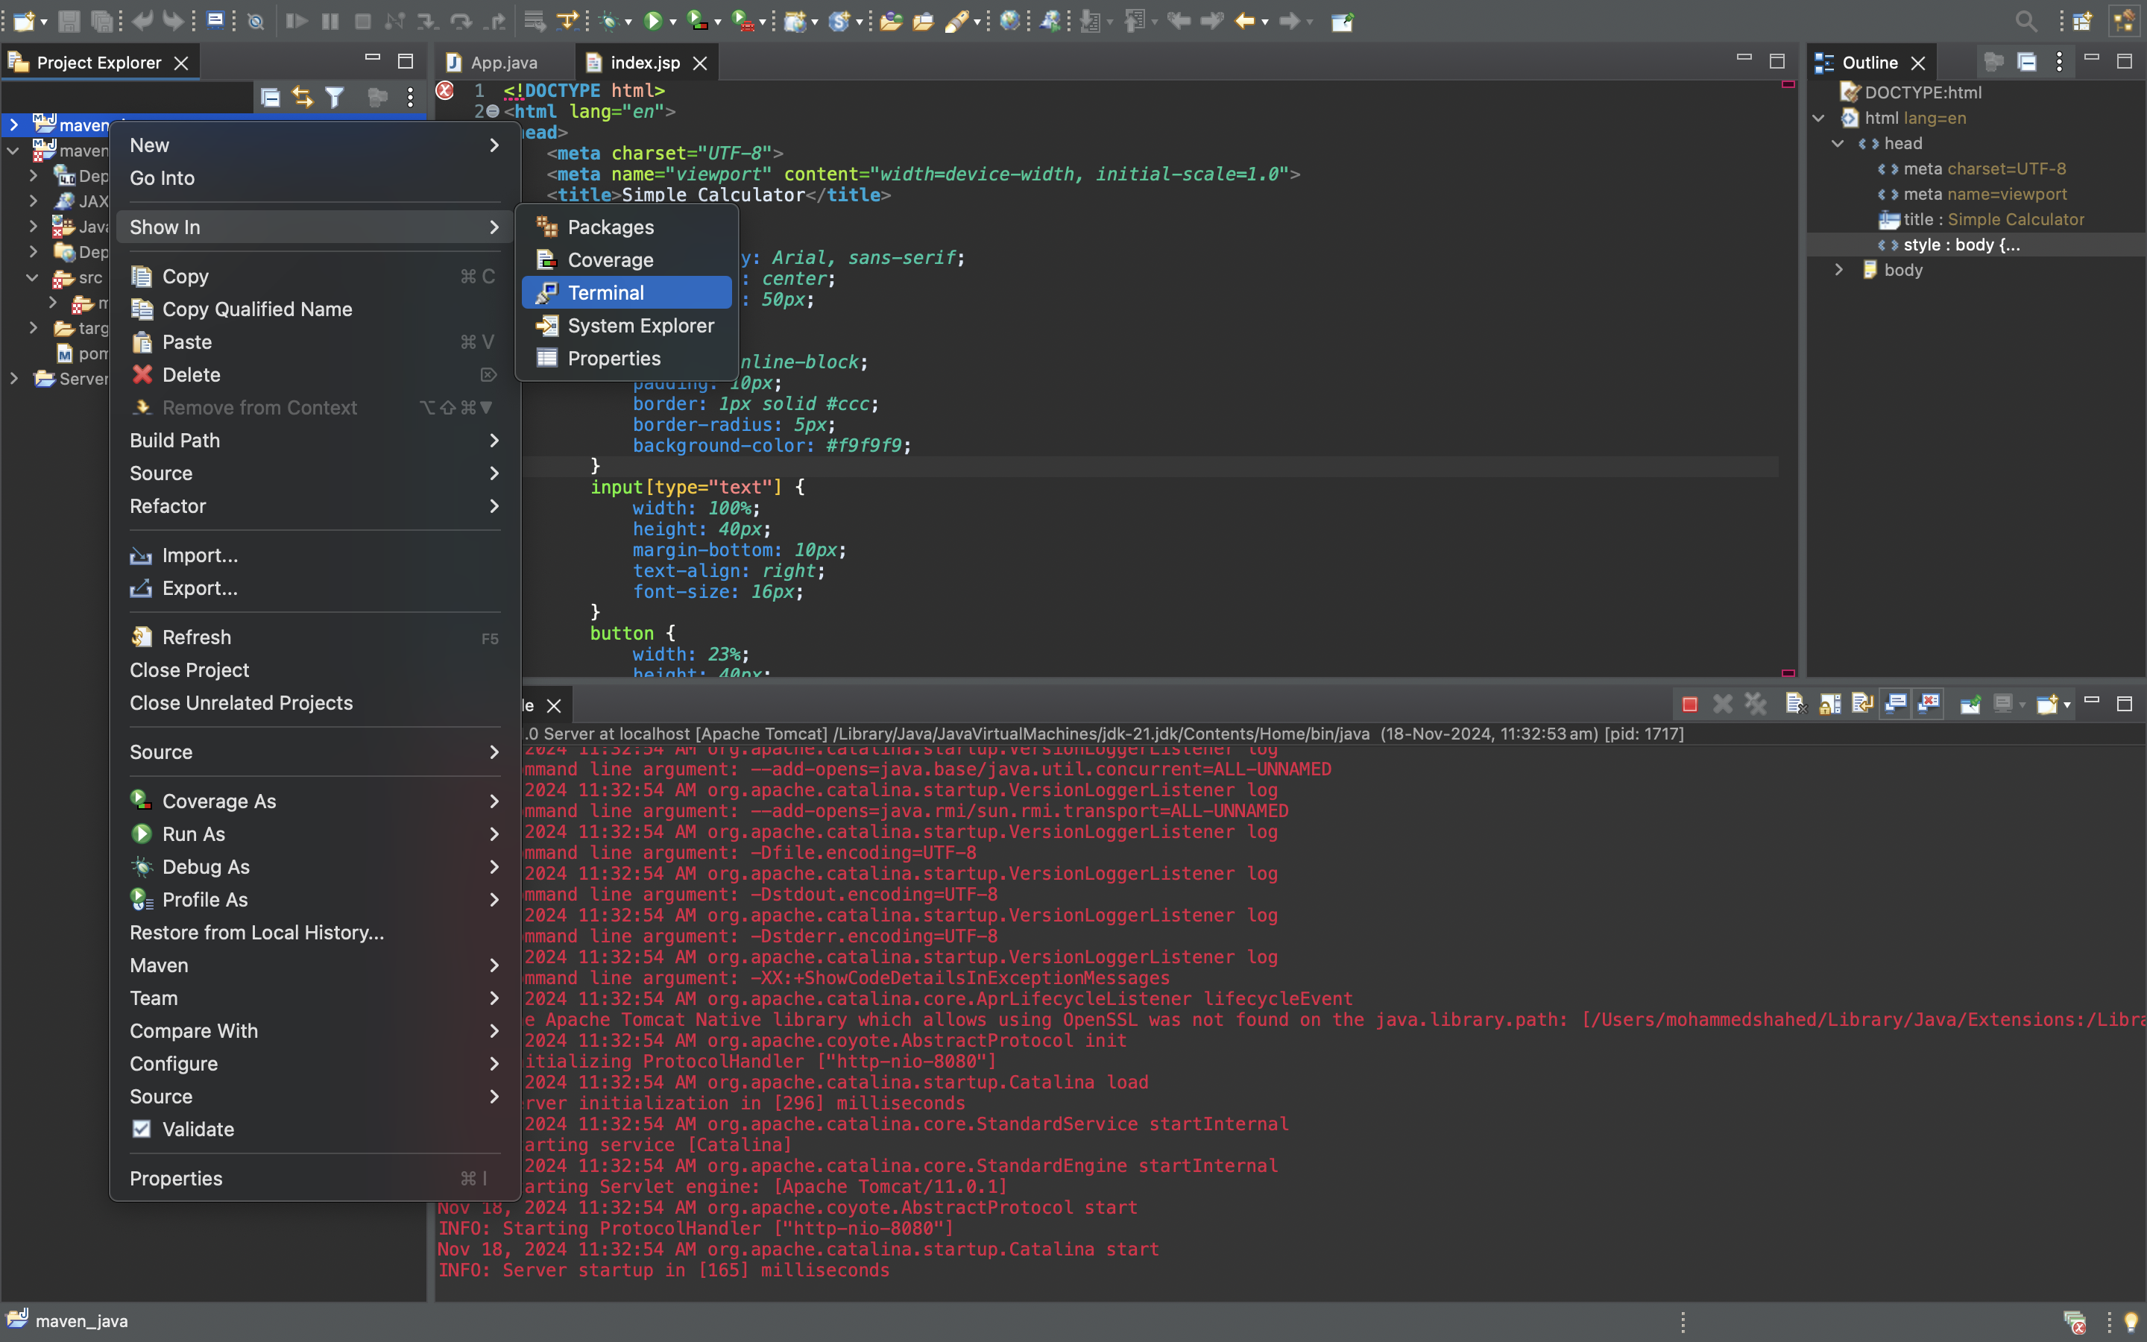

**13.Push the files into git hub**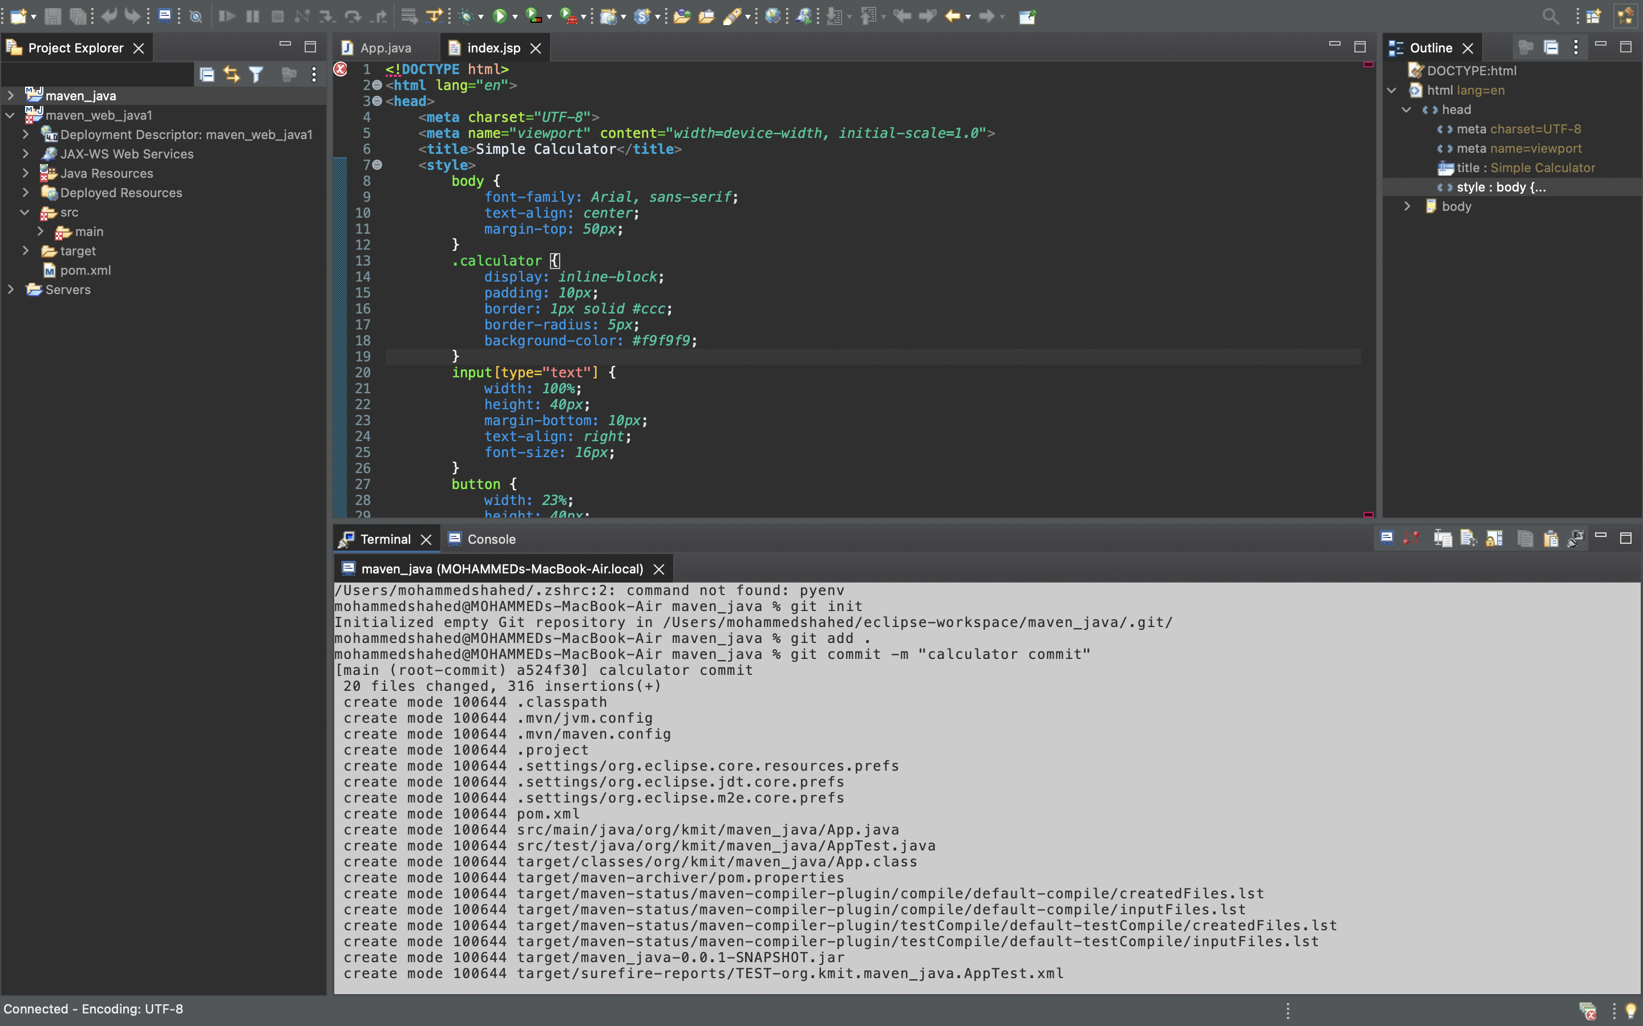

**14.Create a new repository in git hub to push the files**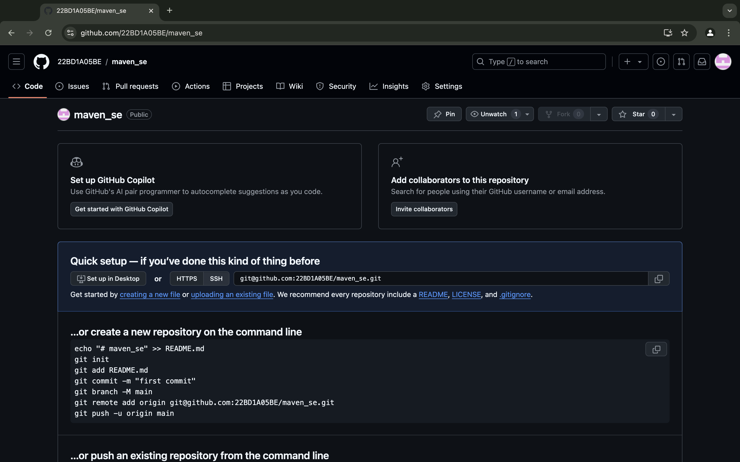

**15.Enter the following commands in order to push**

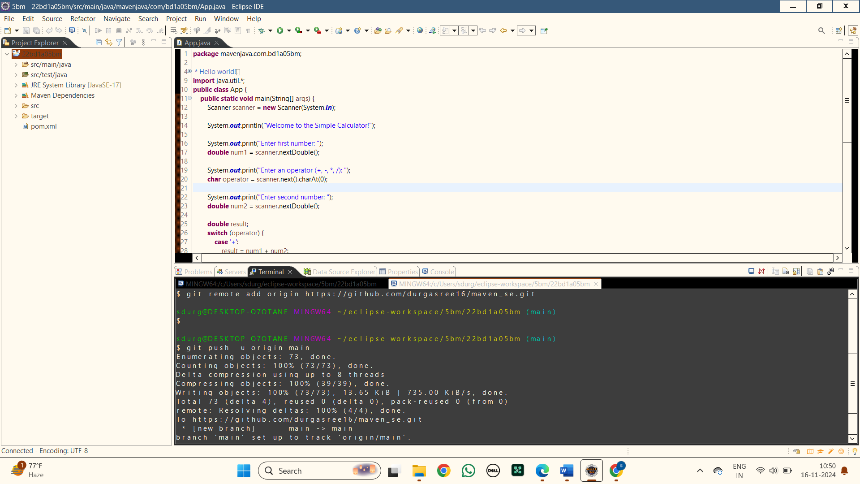

**16.Here are the files pushed into git hub of the MAVEN PROJECT**

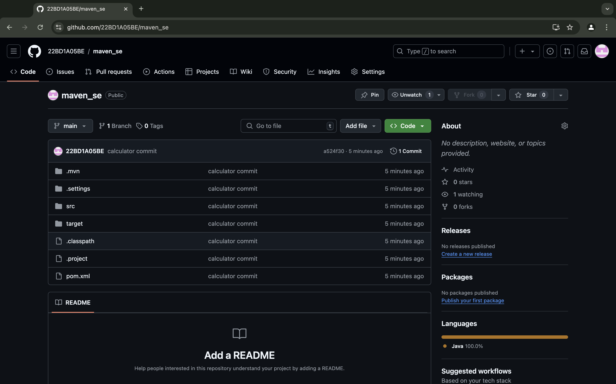

**17. Here is the link for the maven project in git hub :**

https://github.com/22BD1A05BE/maven_se.git

**MAVEN WEB PROJECT**

**1.Creating a new maven java project in eclipse :** Select Project name and location ,use default workspace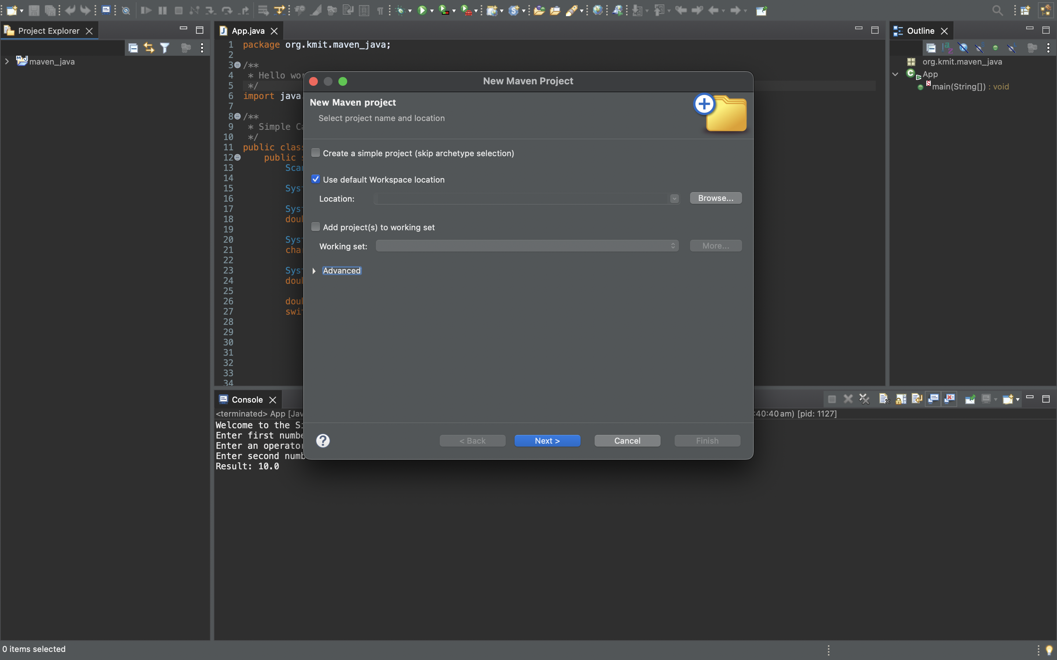

**2.Select An Archetype:** Selecting the archetype as webapp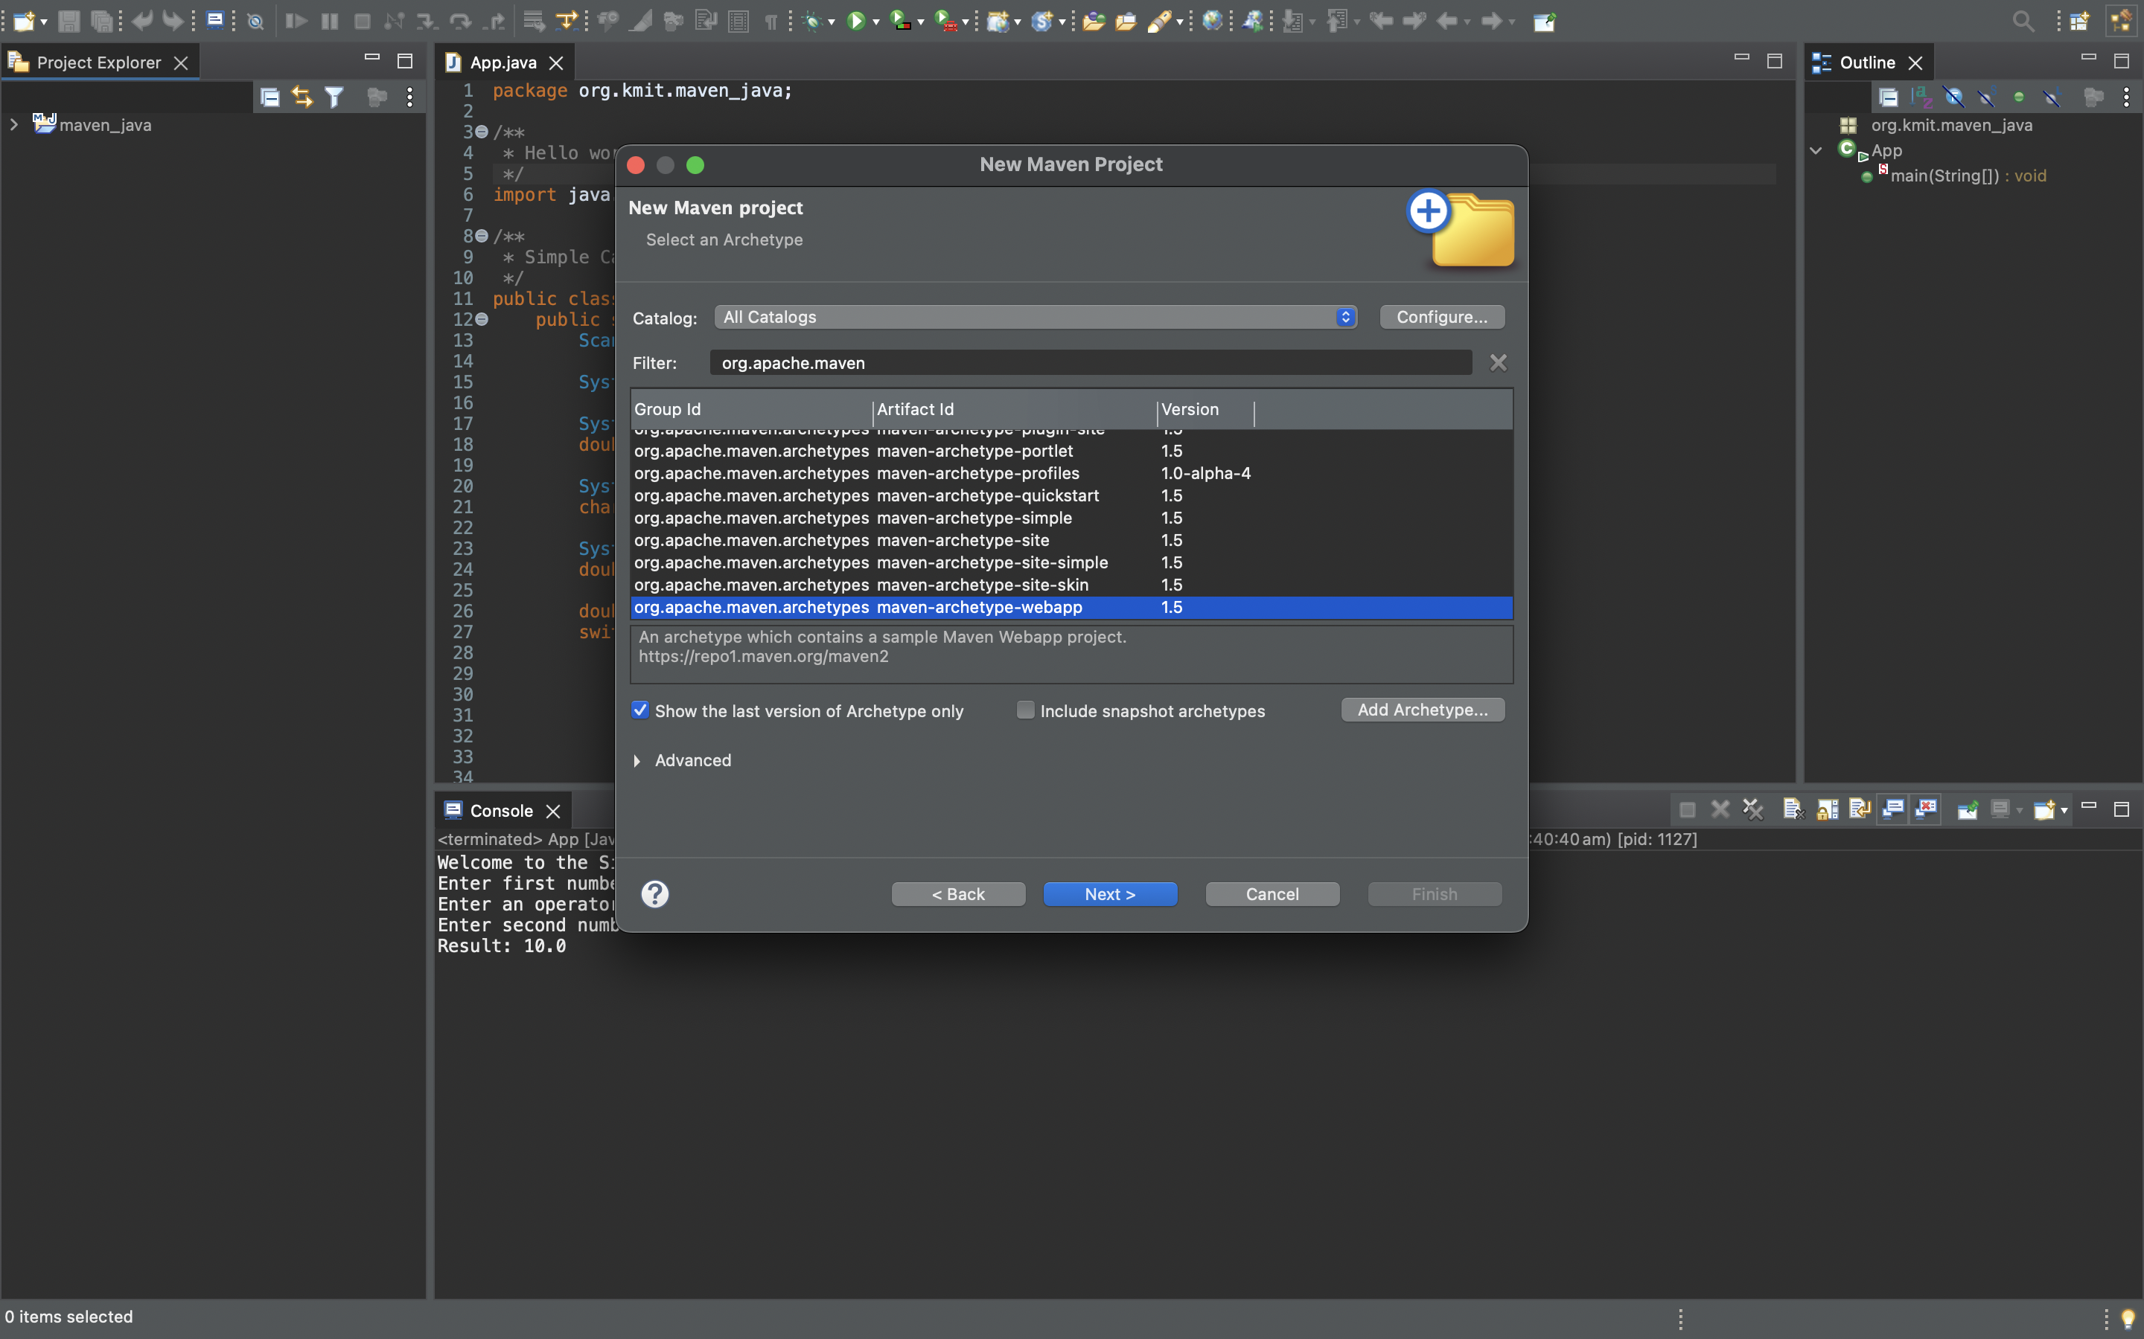

**3.Specify Archetype parameters :** Add GroupId as com.kmit and Artifact Id as maven_web_java1 or else any other name for ArtifactId and finish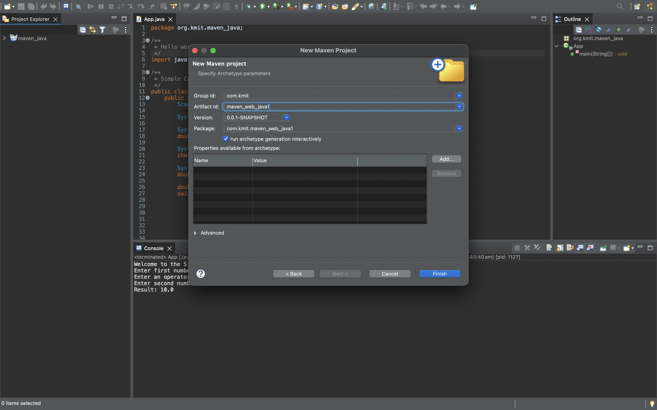

**4.Building of a new maven project is done**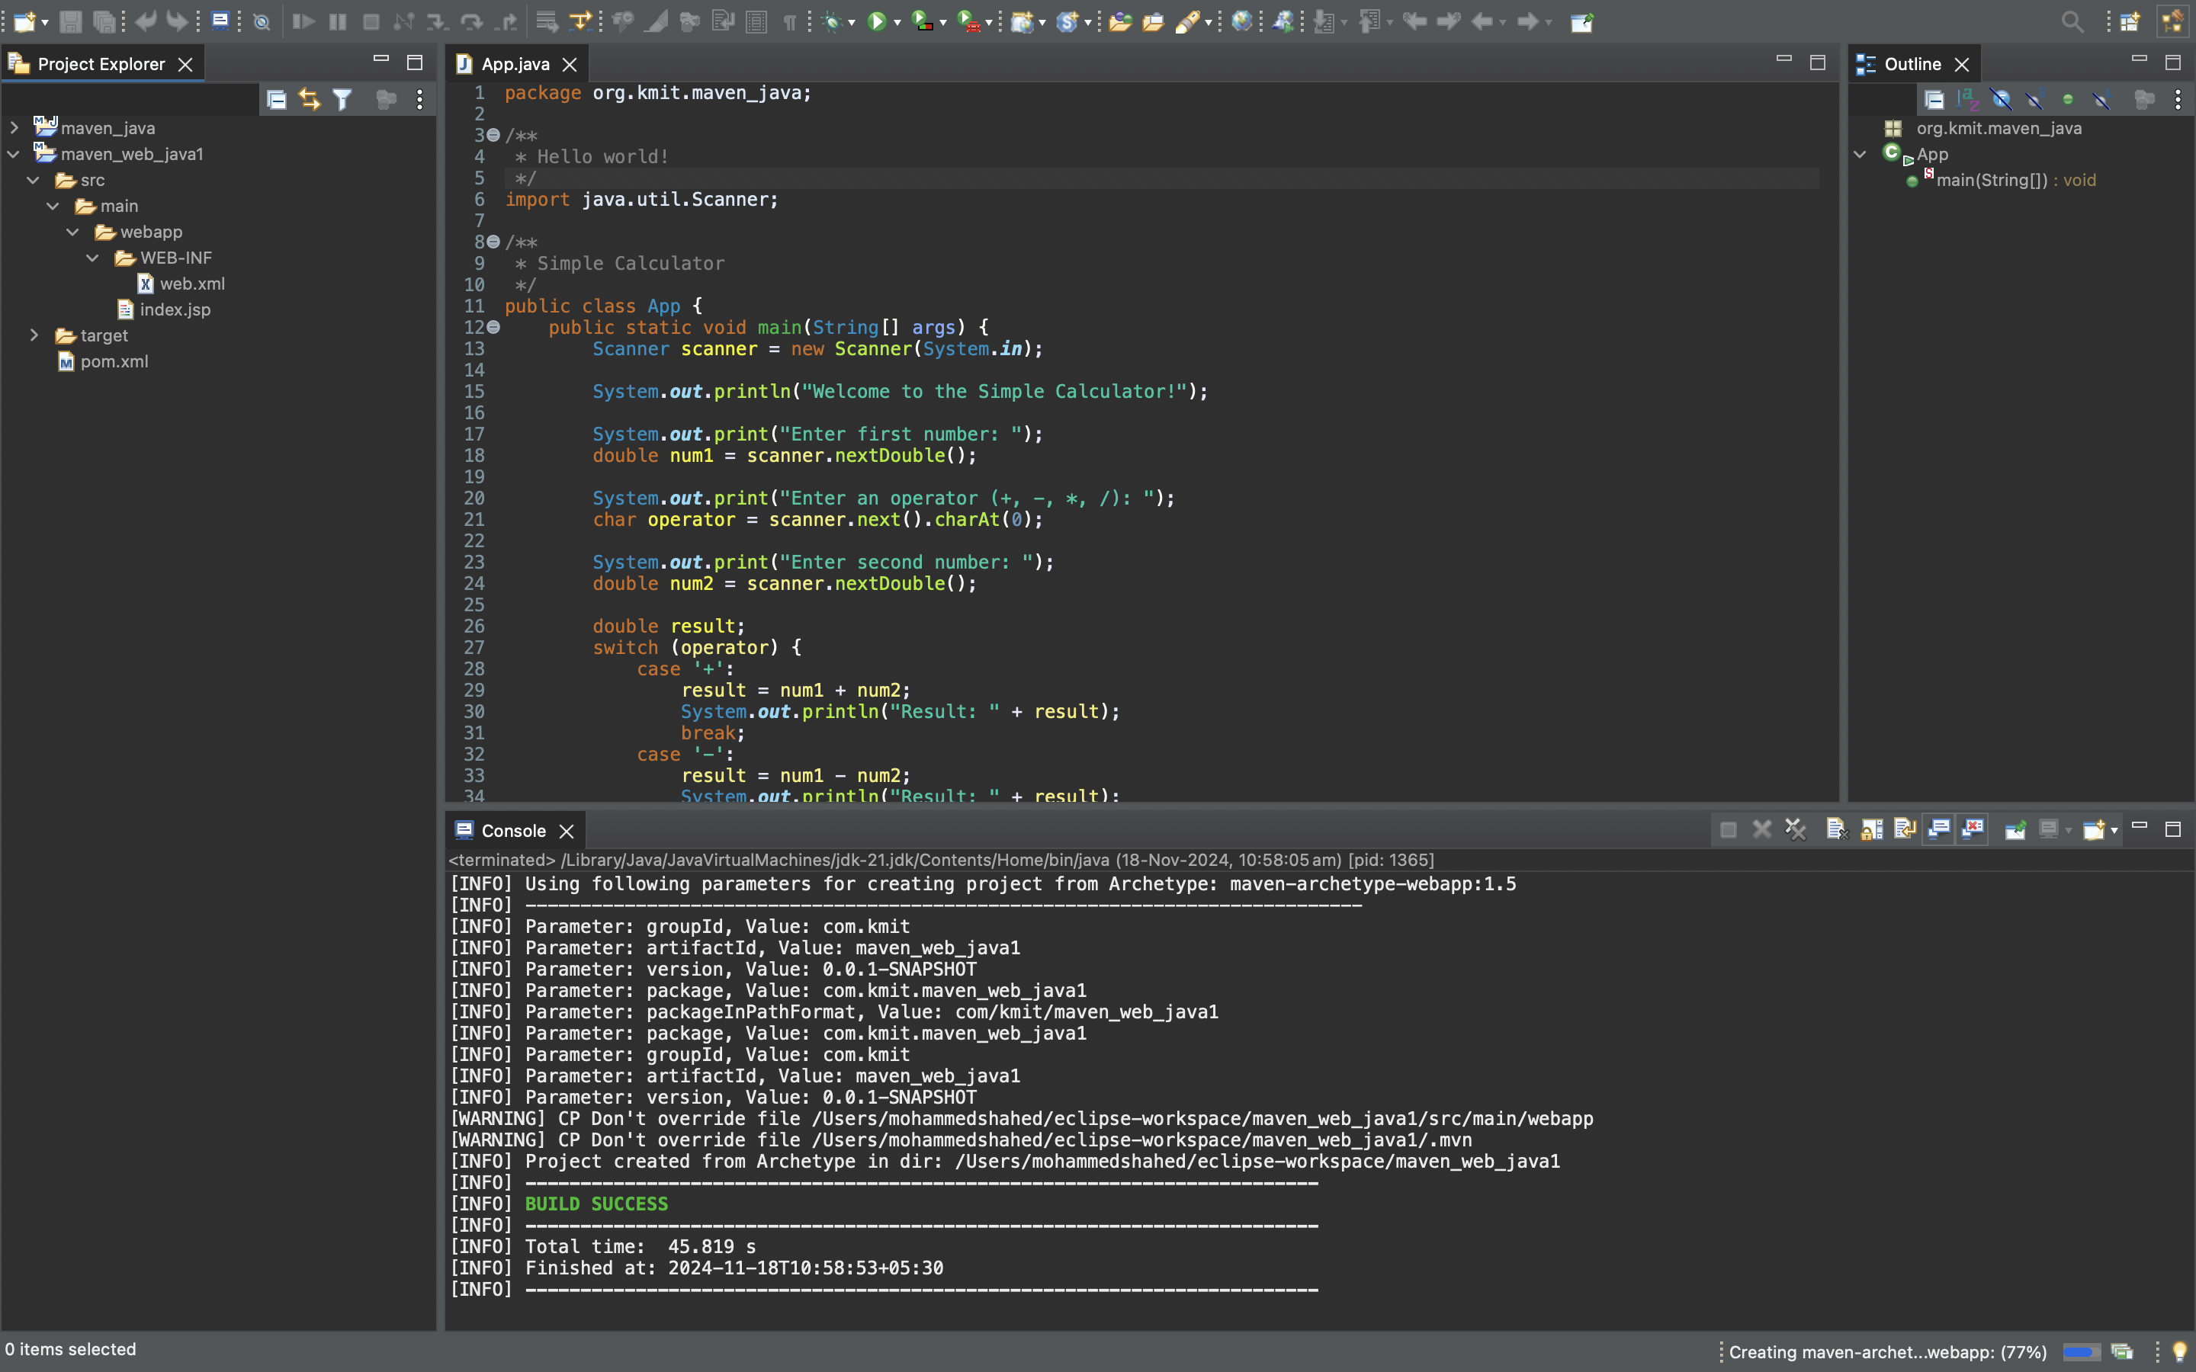

**6.Open App.java:** Open app.java file in the folder src>main>webapp>WEB-INF>index.jsp and write a simple html code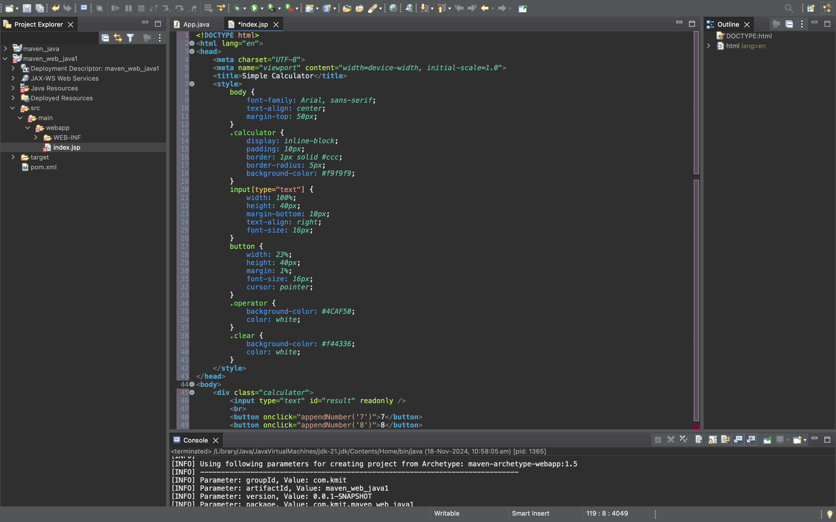

**7.Maven Clean :**Right click the maven project file and select Run as the select Maven clean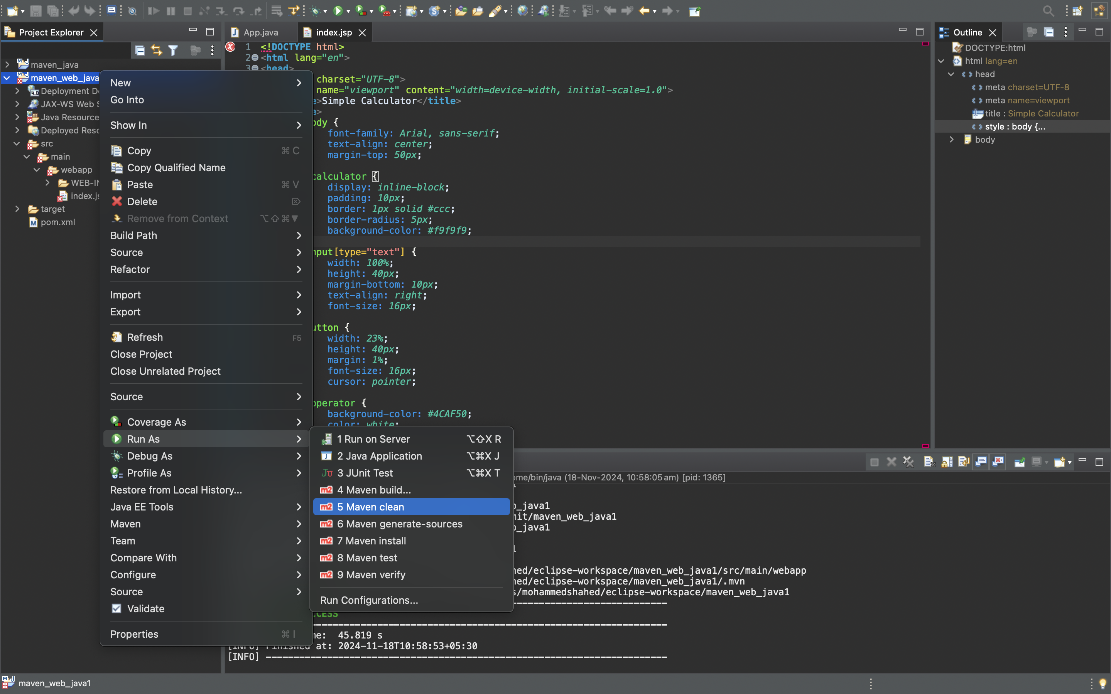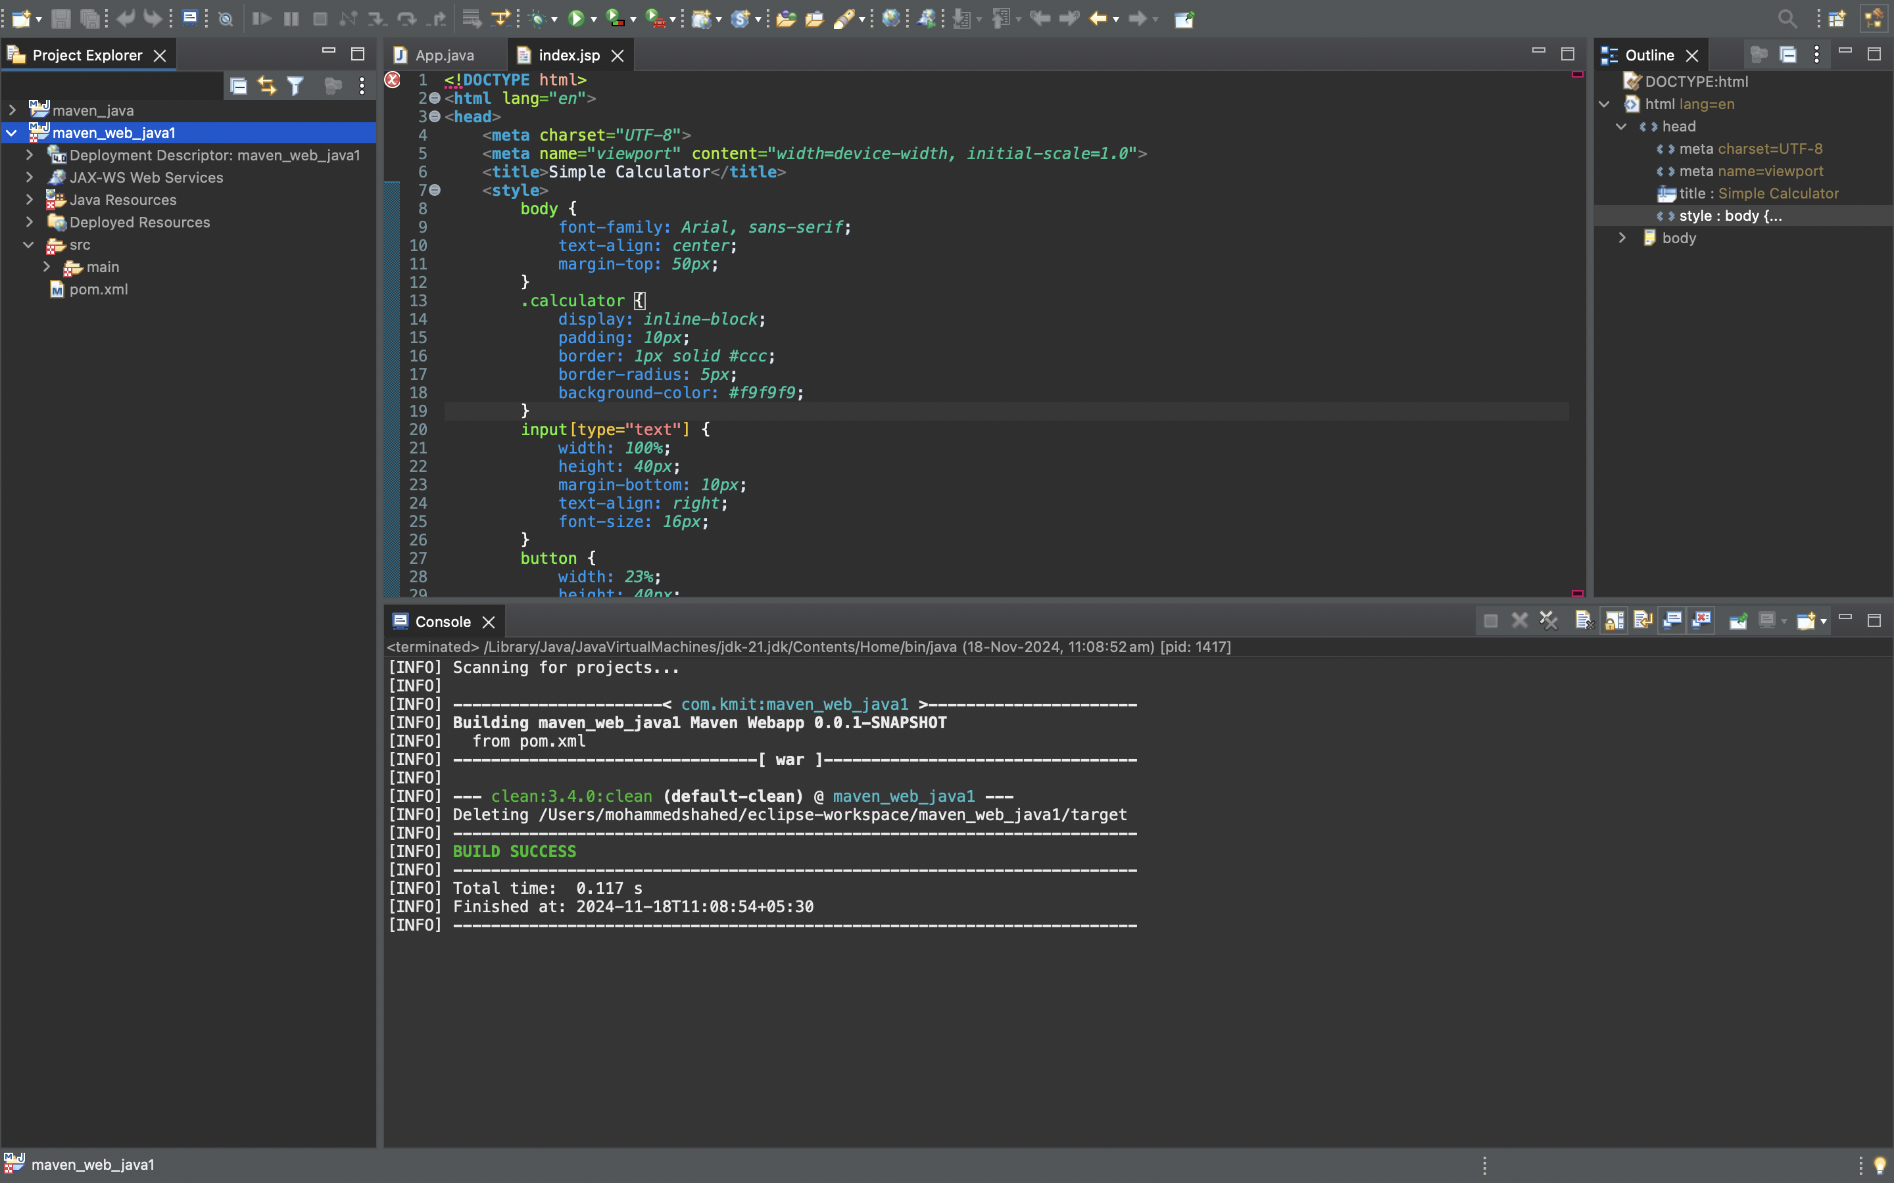

**8.Maven install :**Right click the maven project file and select Run as the select Maven install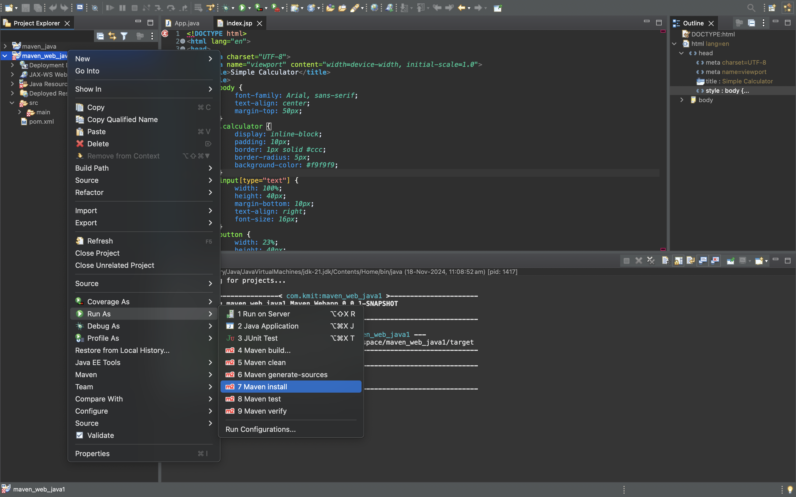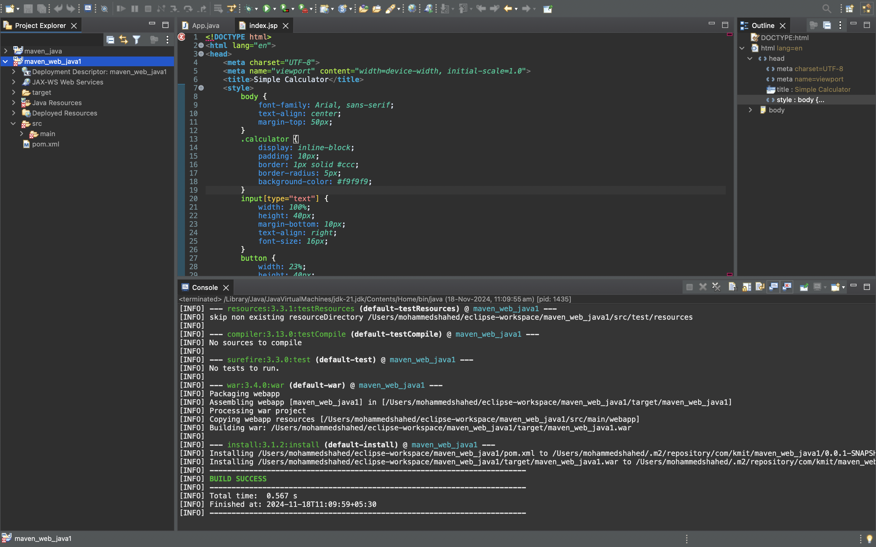

**9.Maven build:**Right click the maven project file and select Run as the select Maven build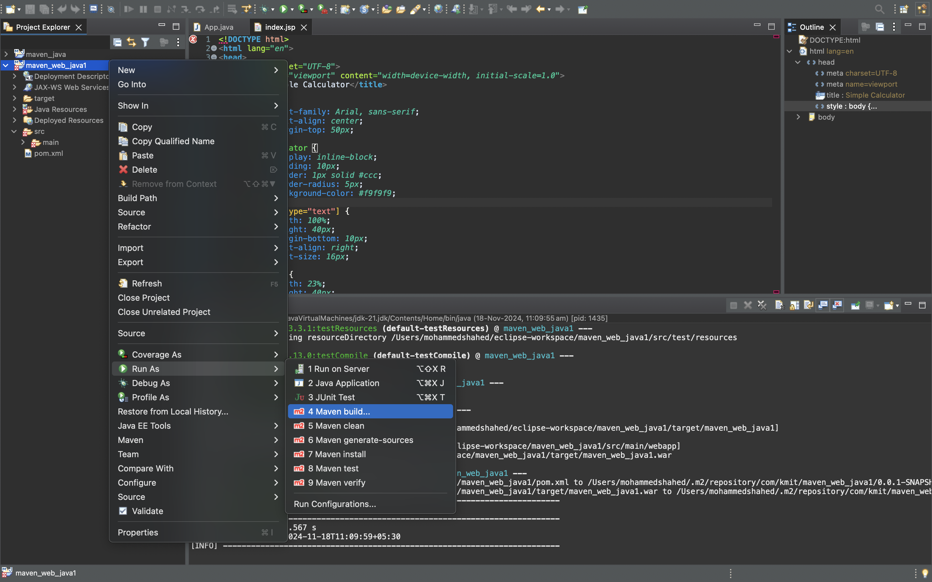

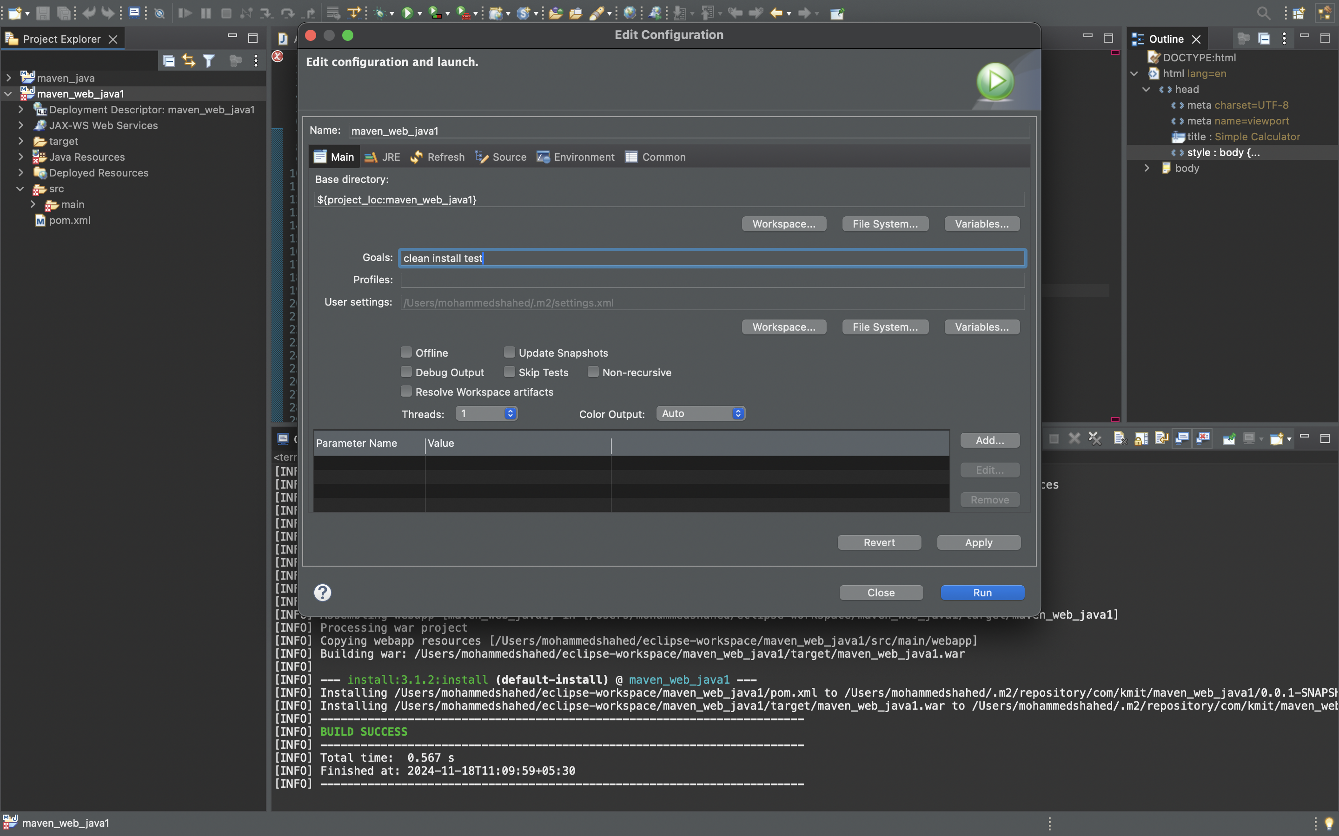

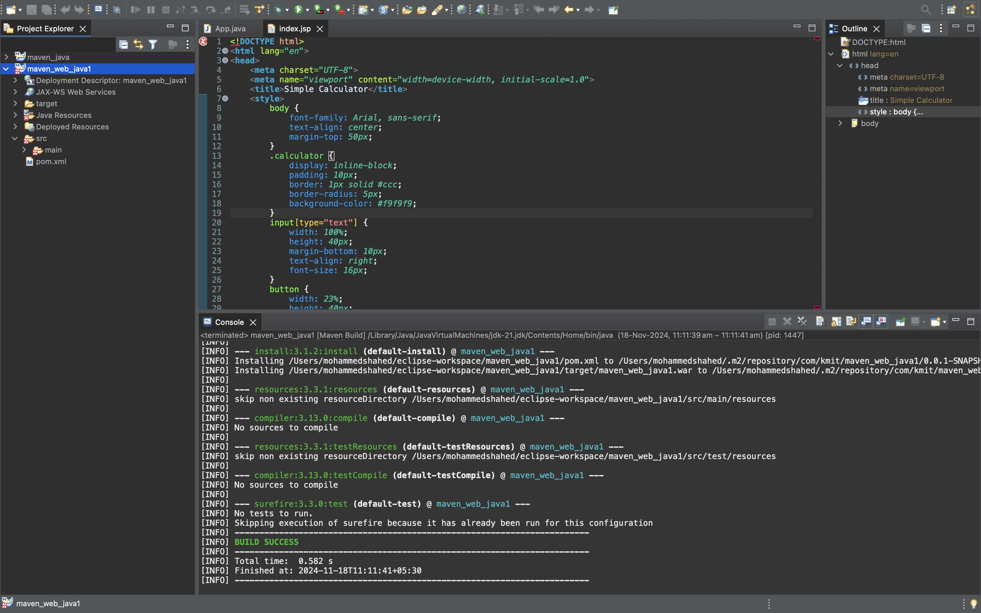

**10.Maven test:** Right click the maven project file and select Run as the select Maven test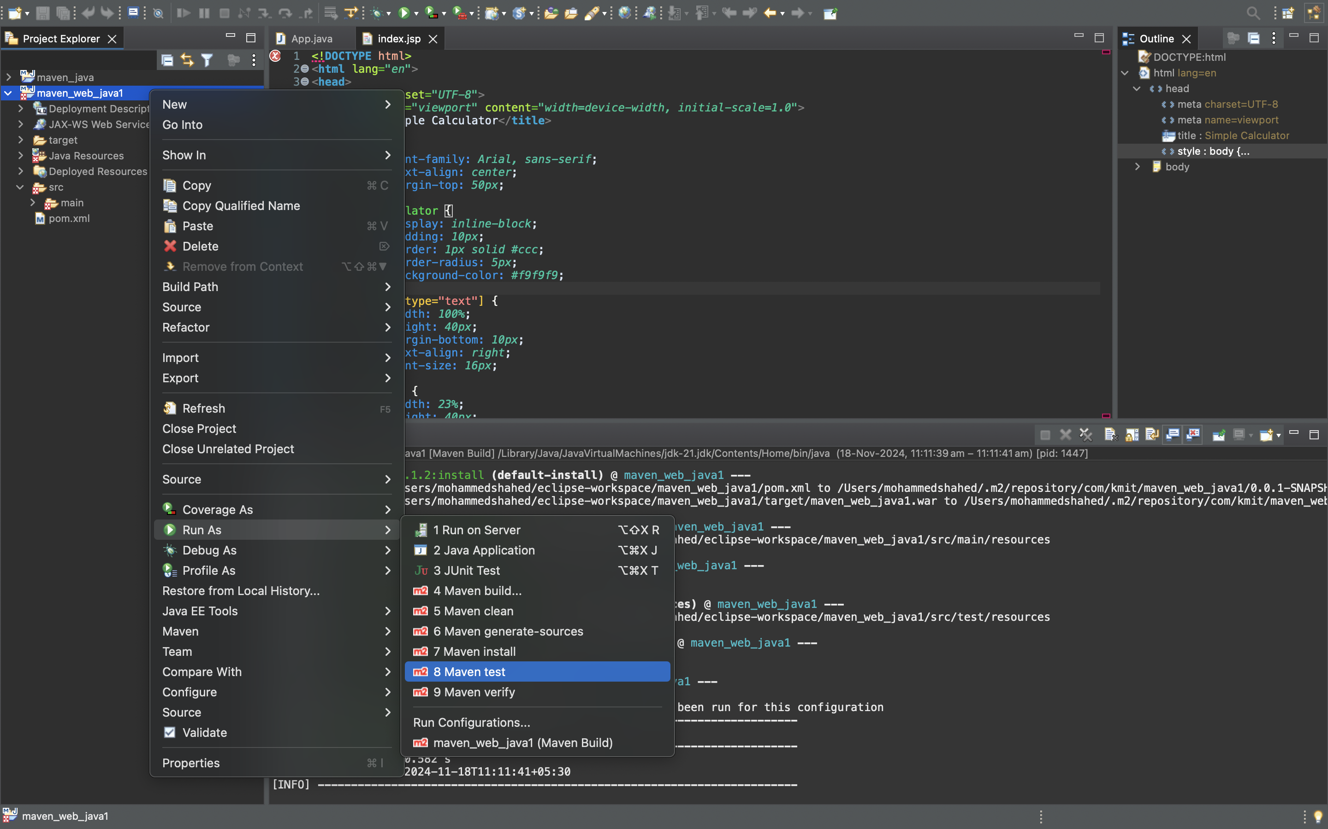

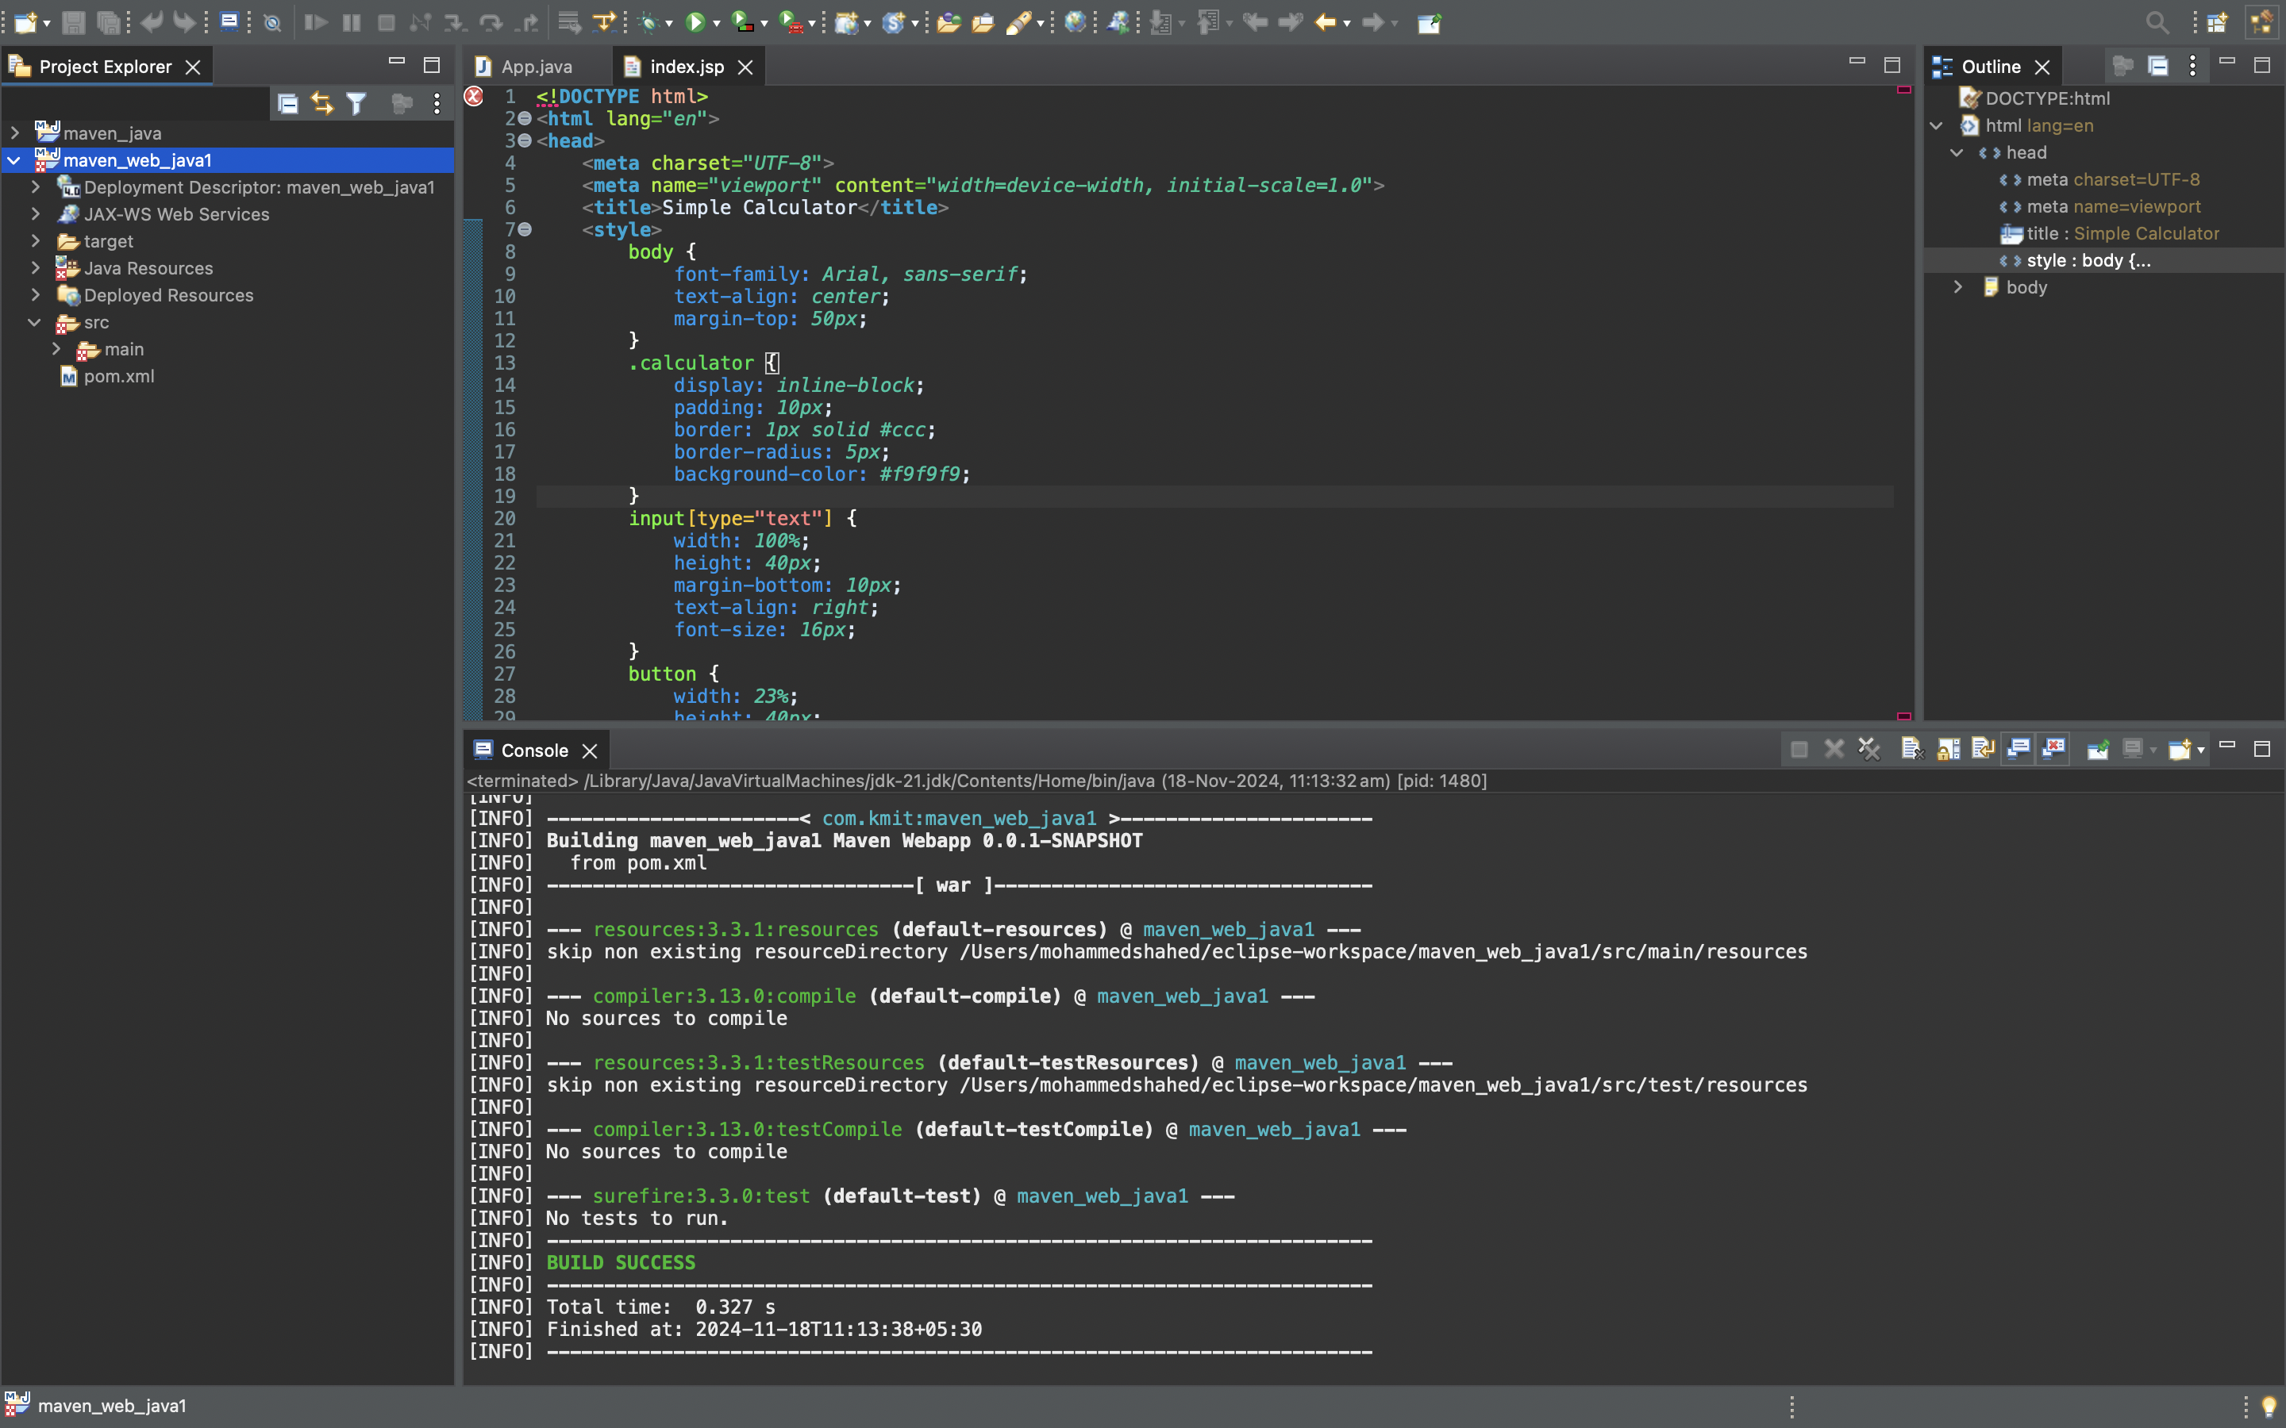

**11.Run as server :** Right click the maven project file and select Run as the select run as server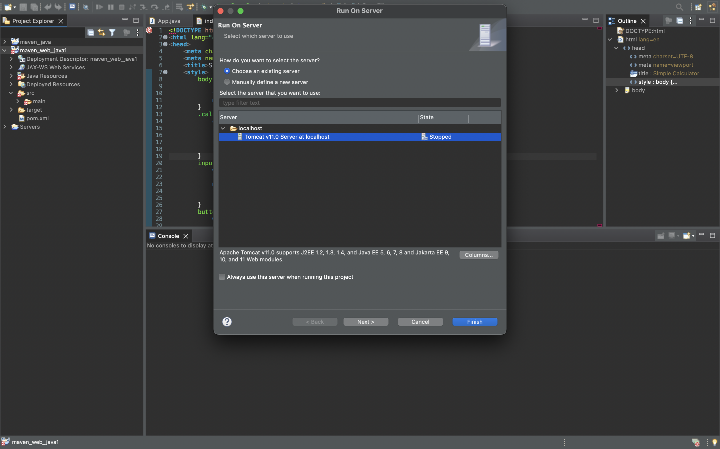

**12.Output:**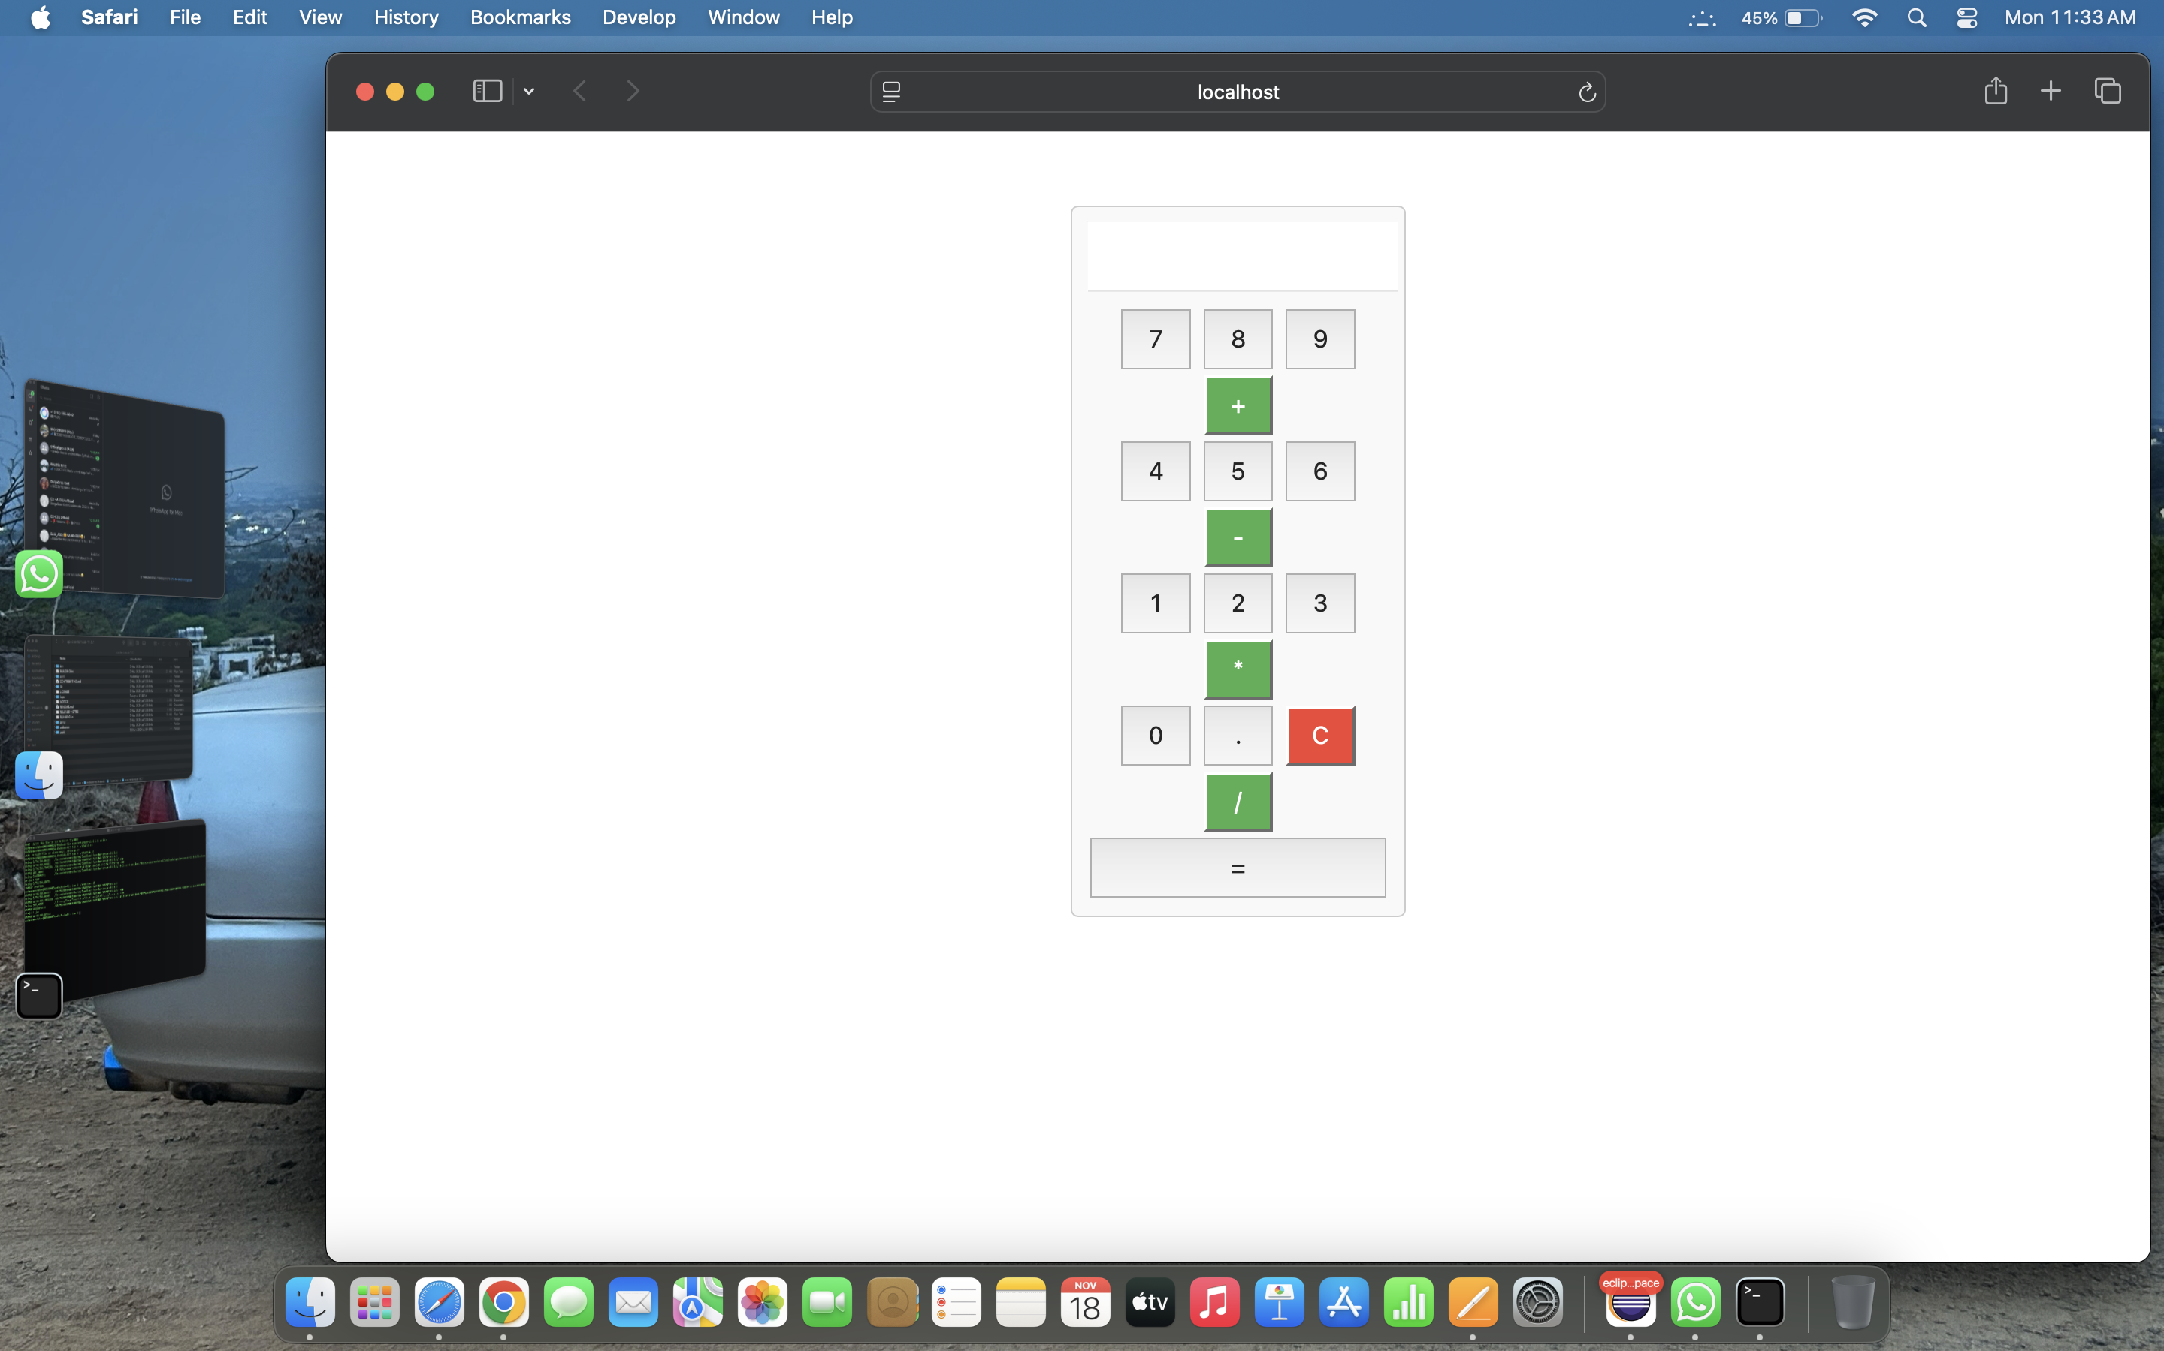

**13.Open with git bash :** Right click the maven project file and select show in local terminal and then select Git bash

**14.Push the files into git hub**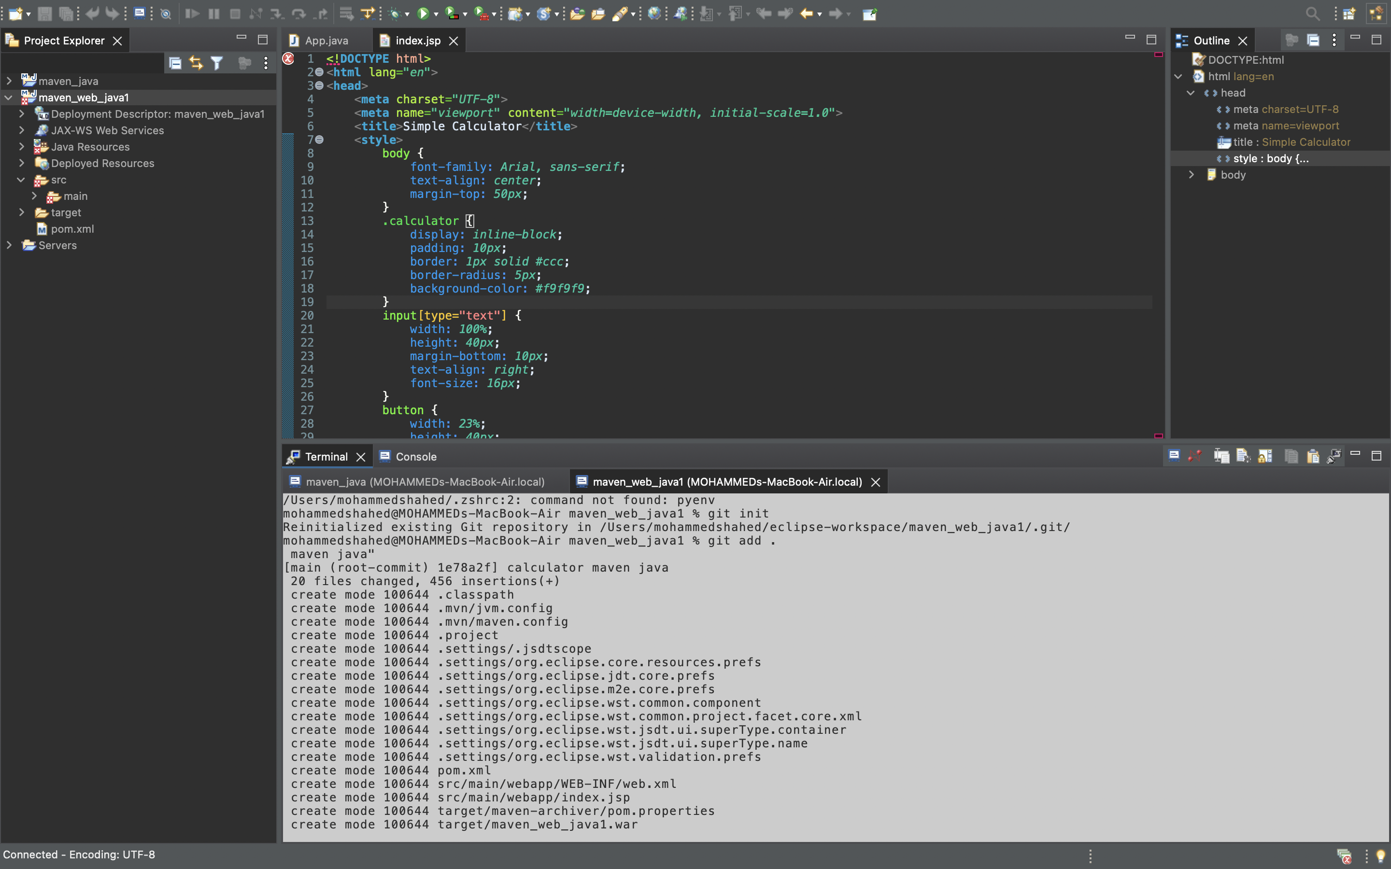

**15.Create a new repository in git hub to push the files**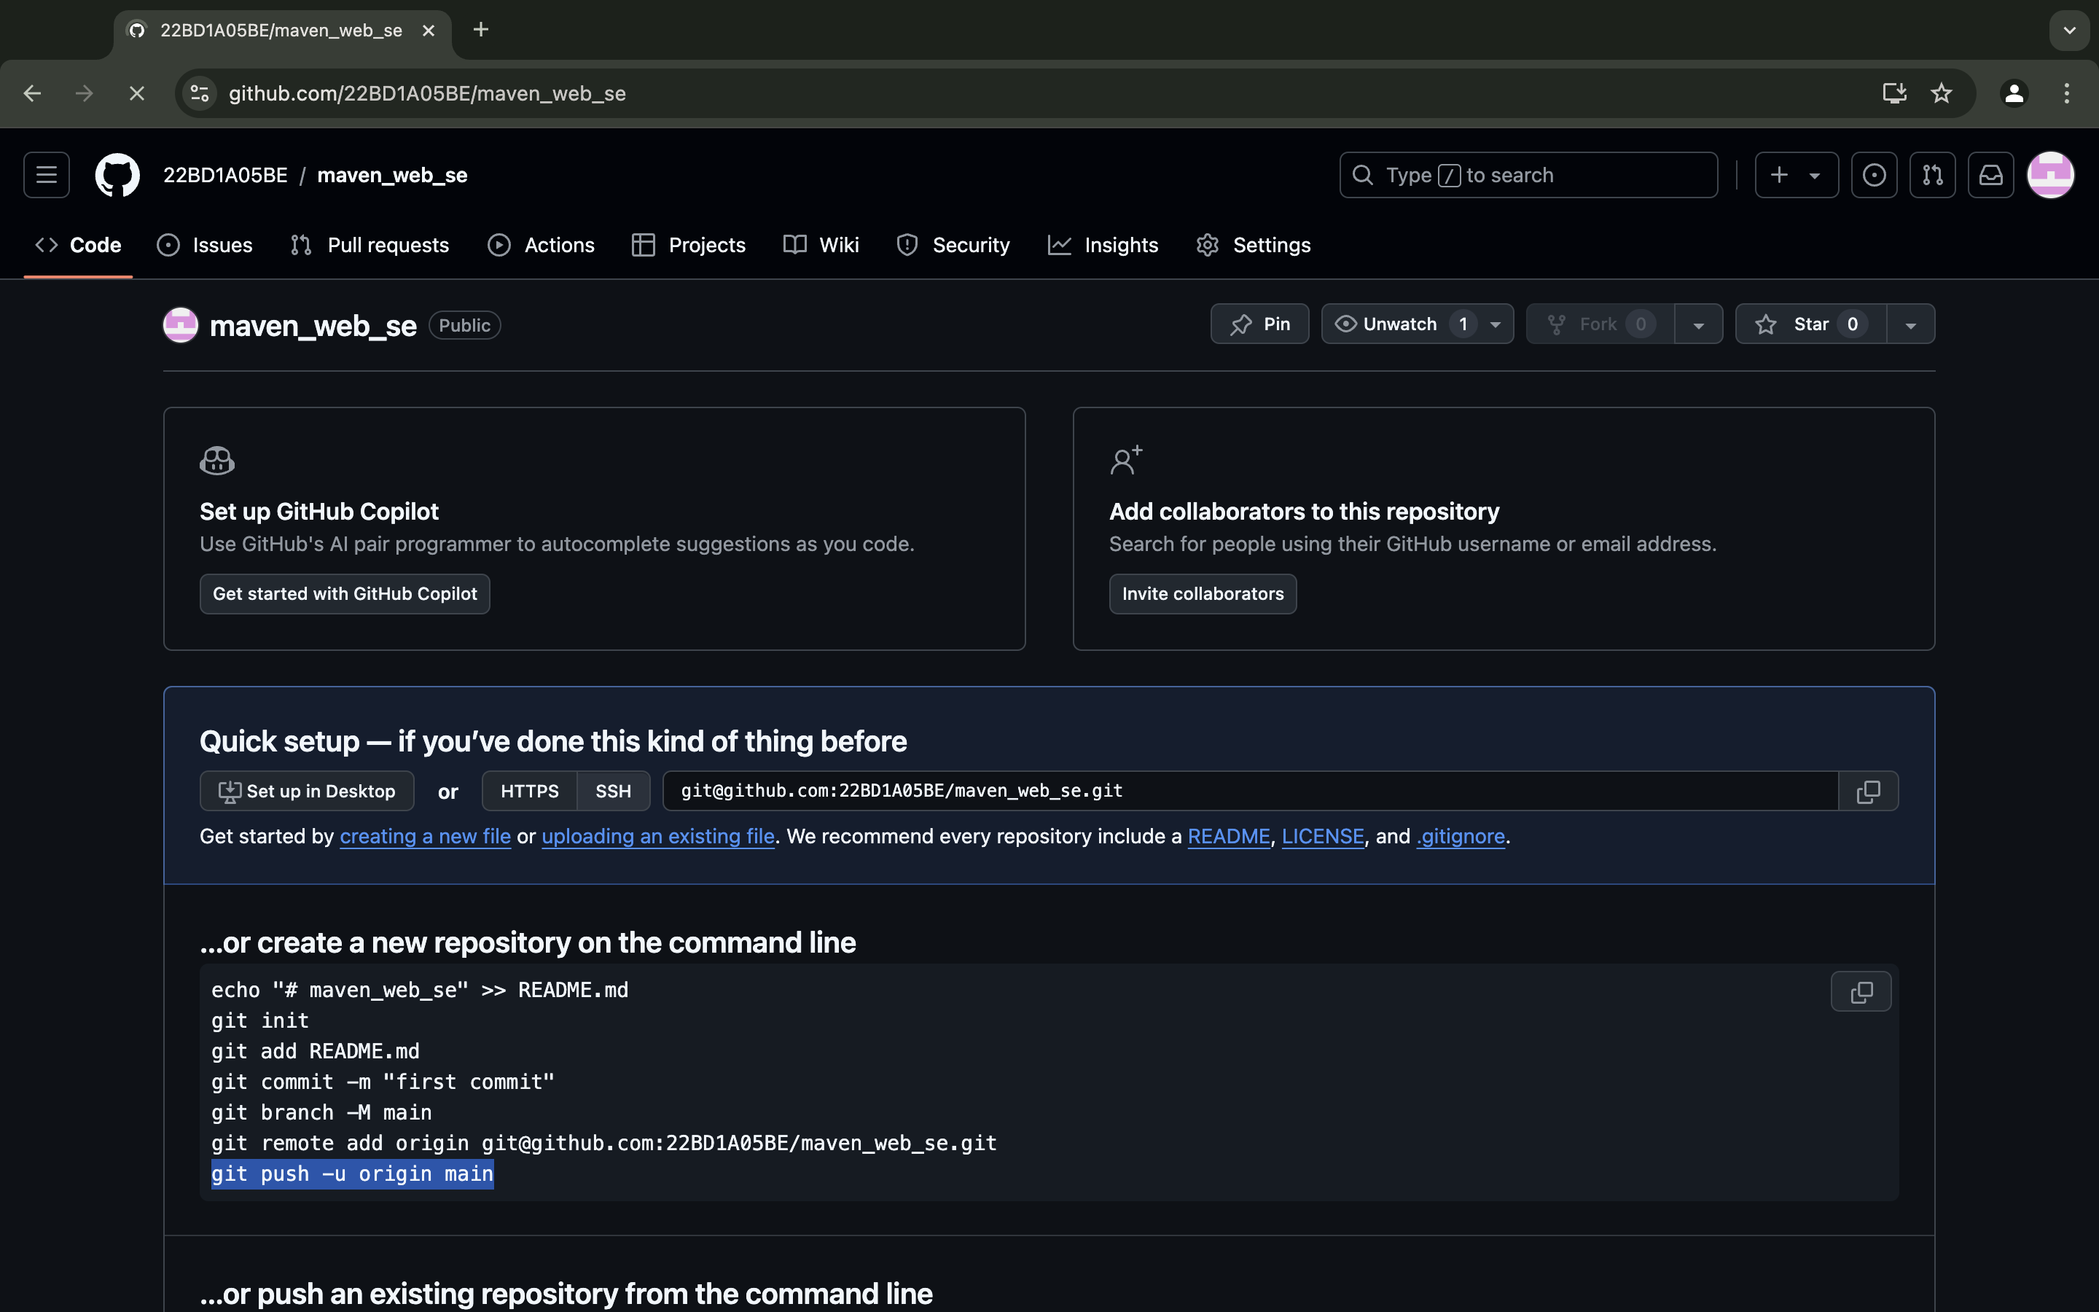

**16.Enter the following commands in order to push**

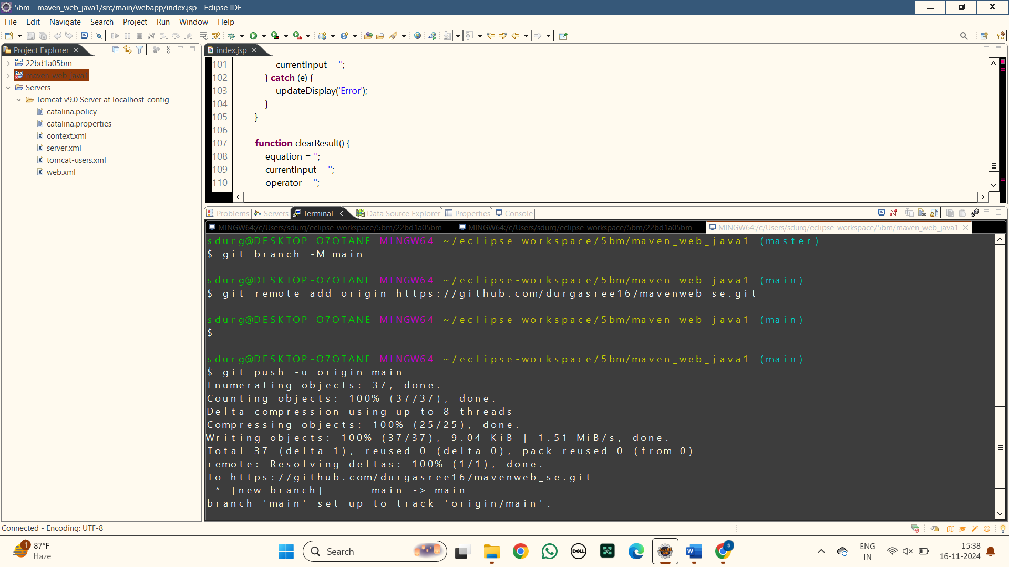

**17.Here are the files pushed into git hub of the MAVEN WEB PROJECT**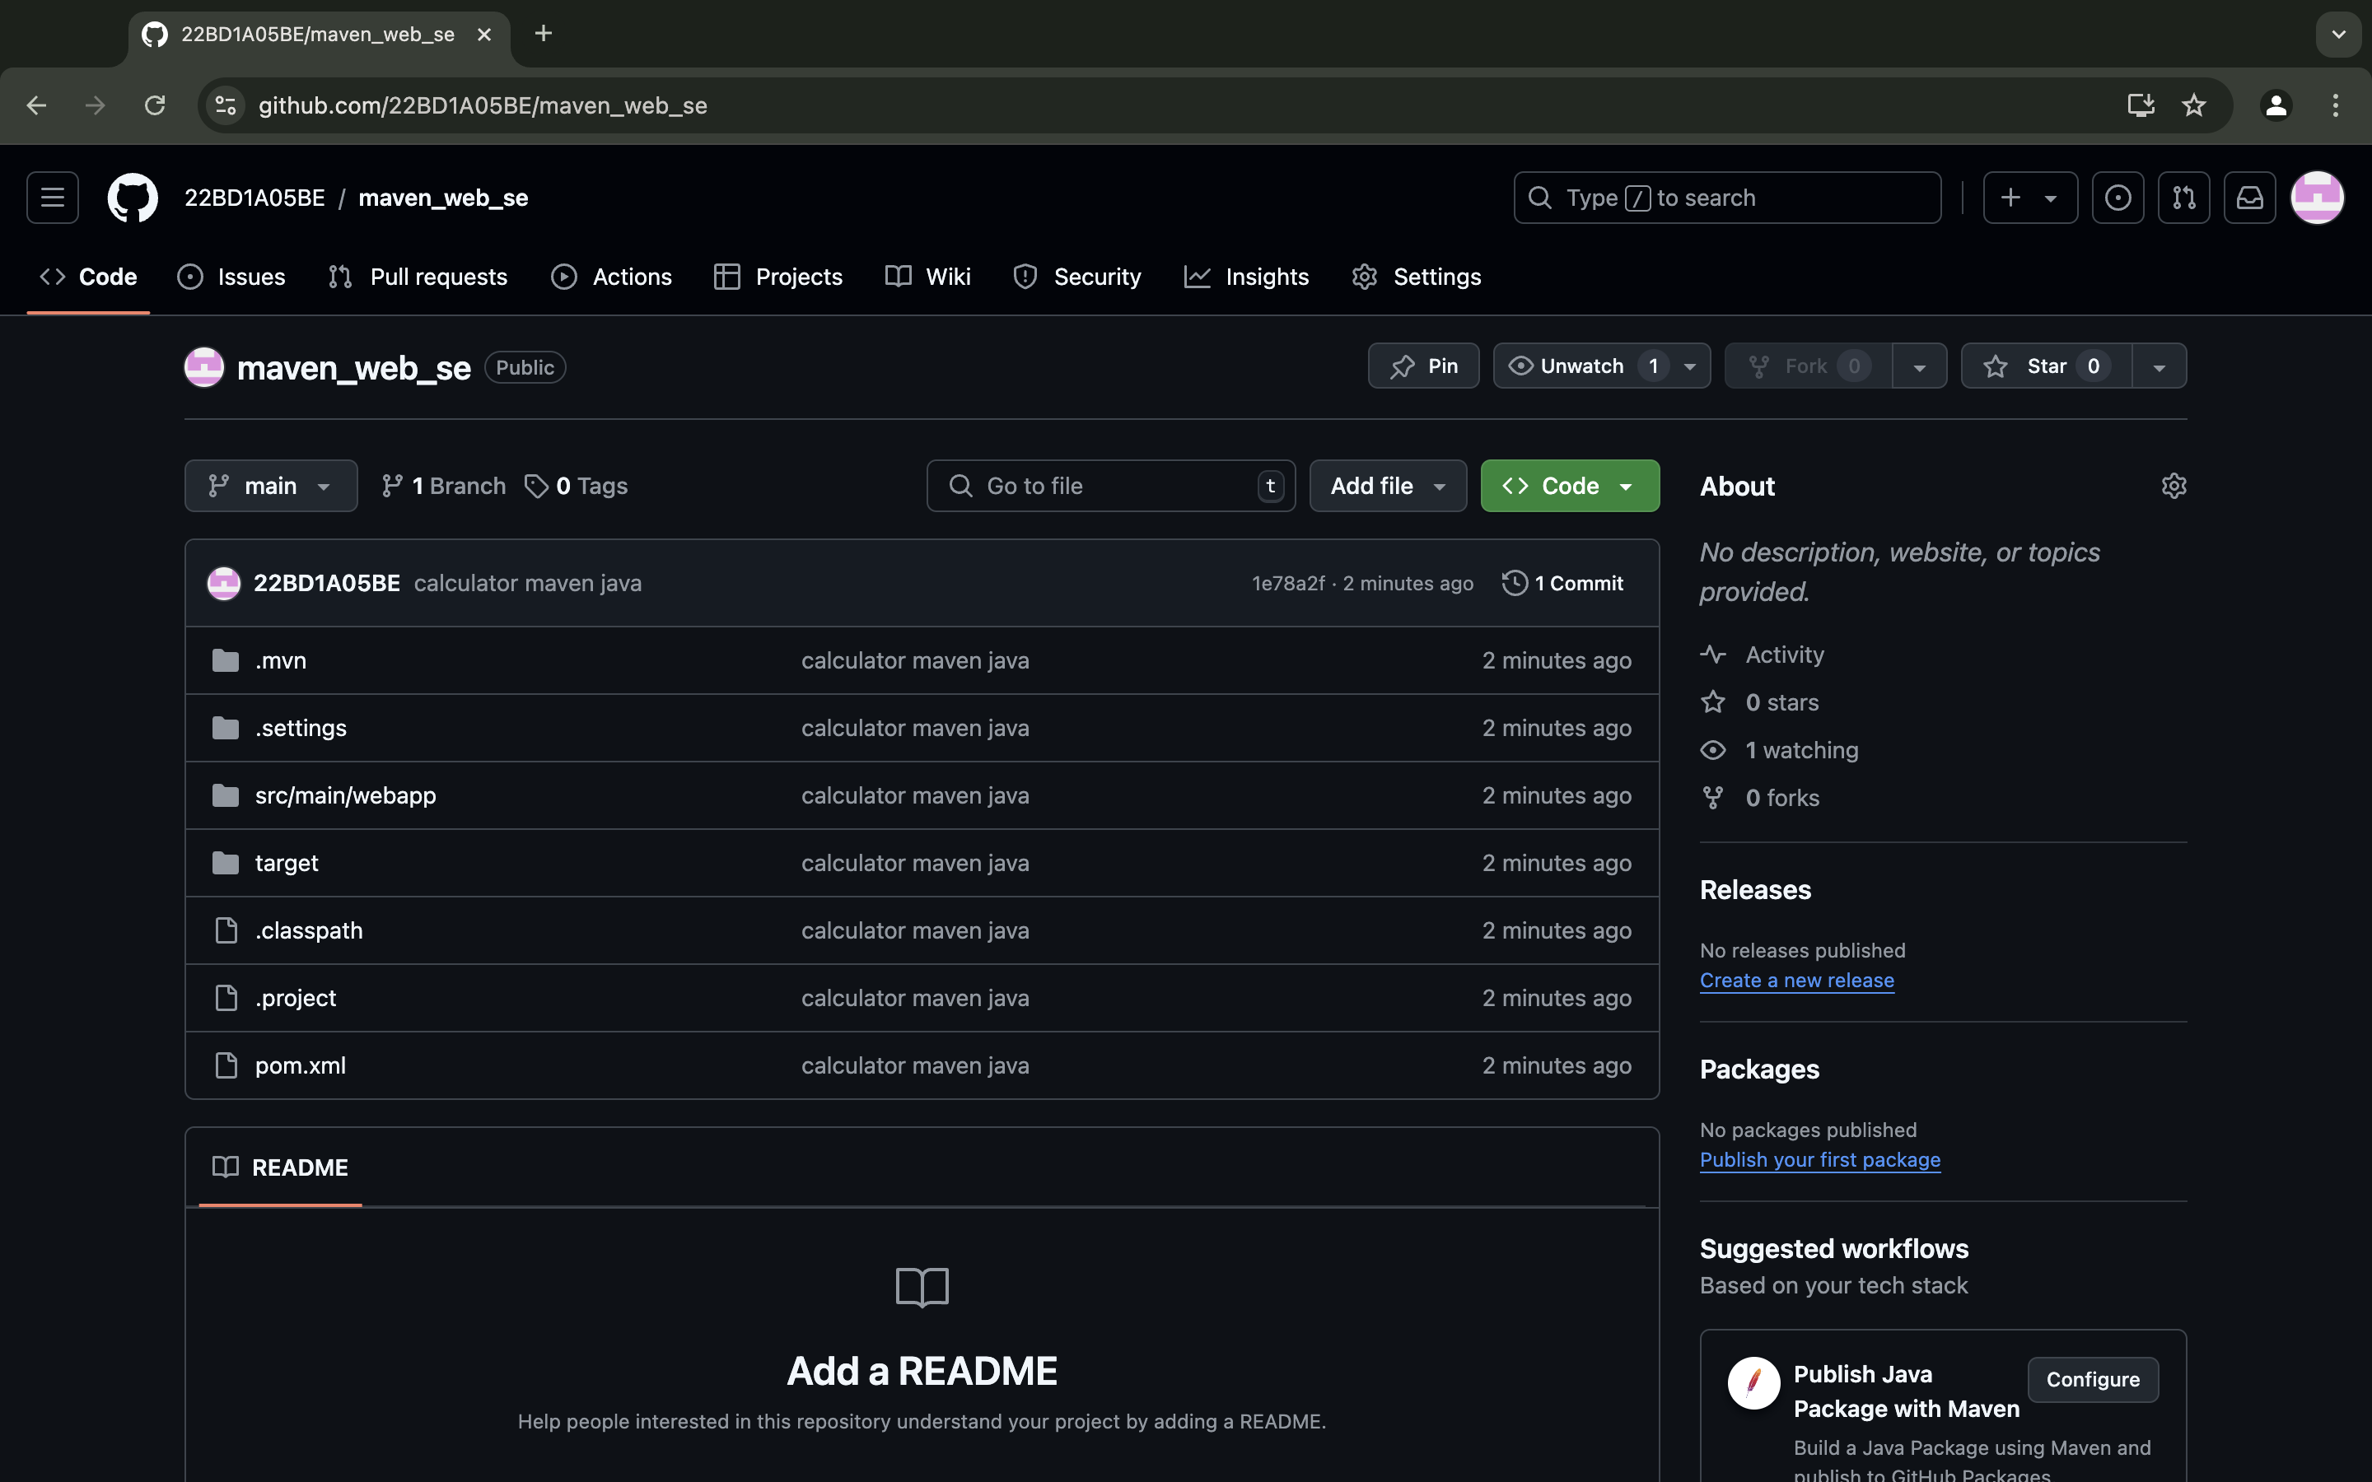

**17. Here is the link for the maven project in git hub :**

https://github.com/22BD1A05BE/maven_web_se.git

1. **Go to <https://www.jenkins.io/download/> and select the platform. In our case it is MAC OS**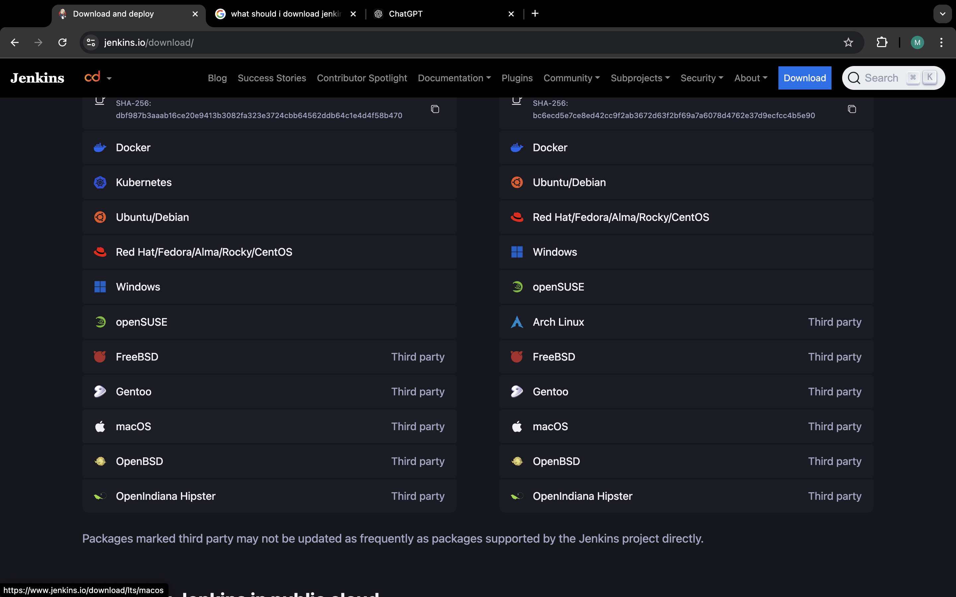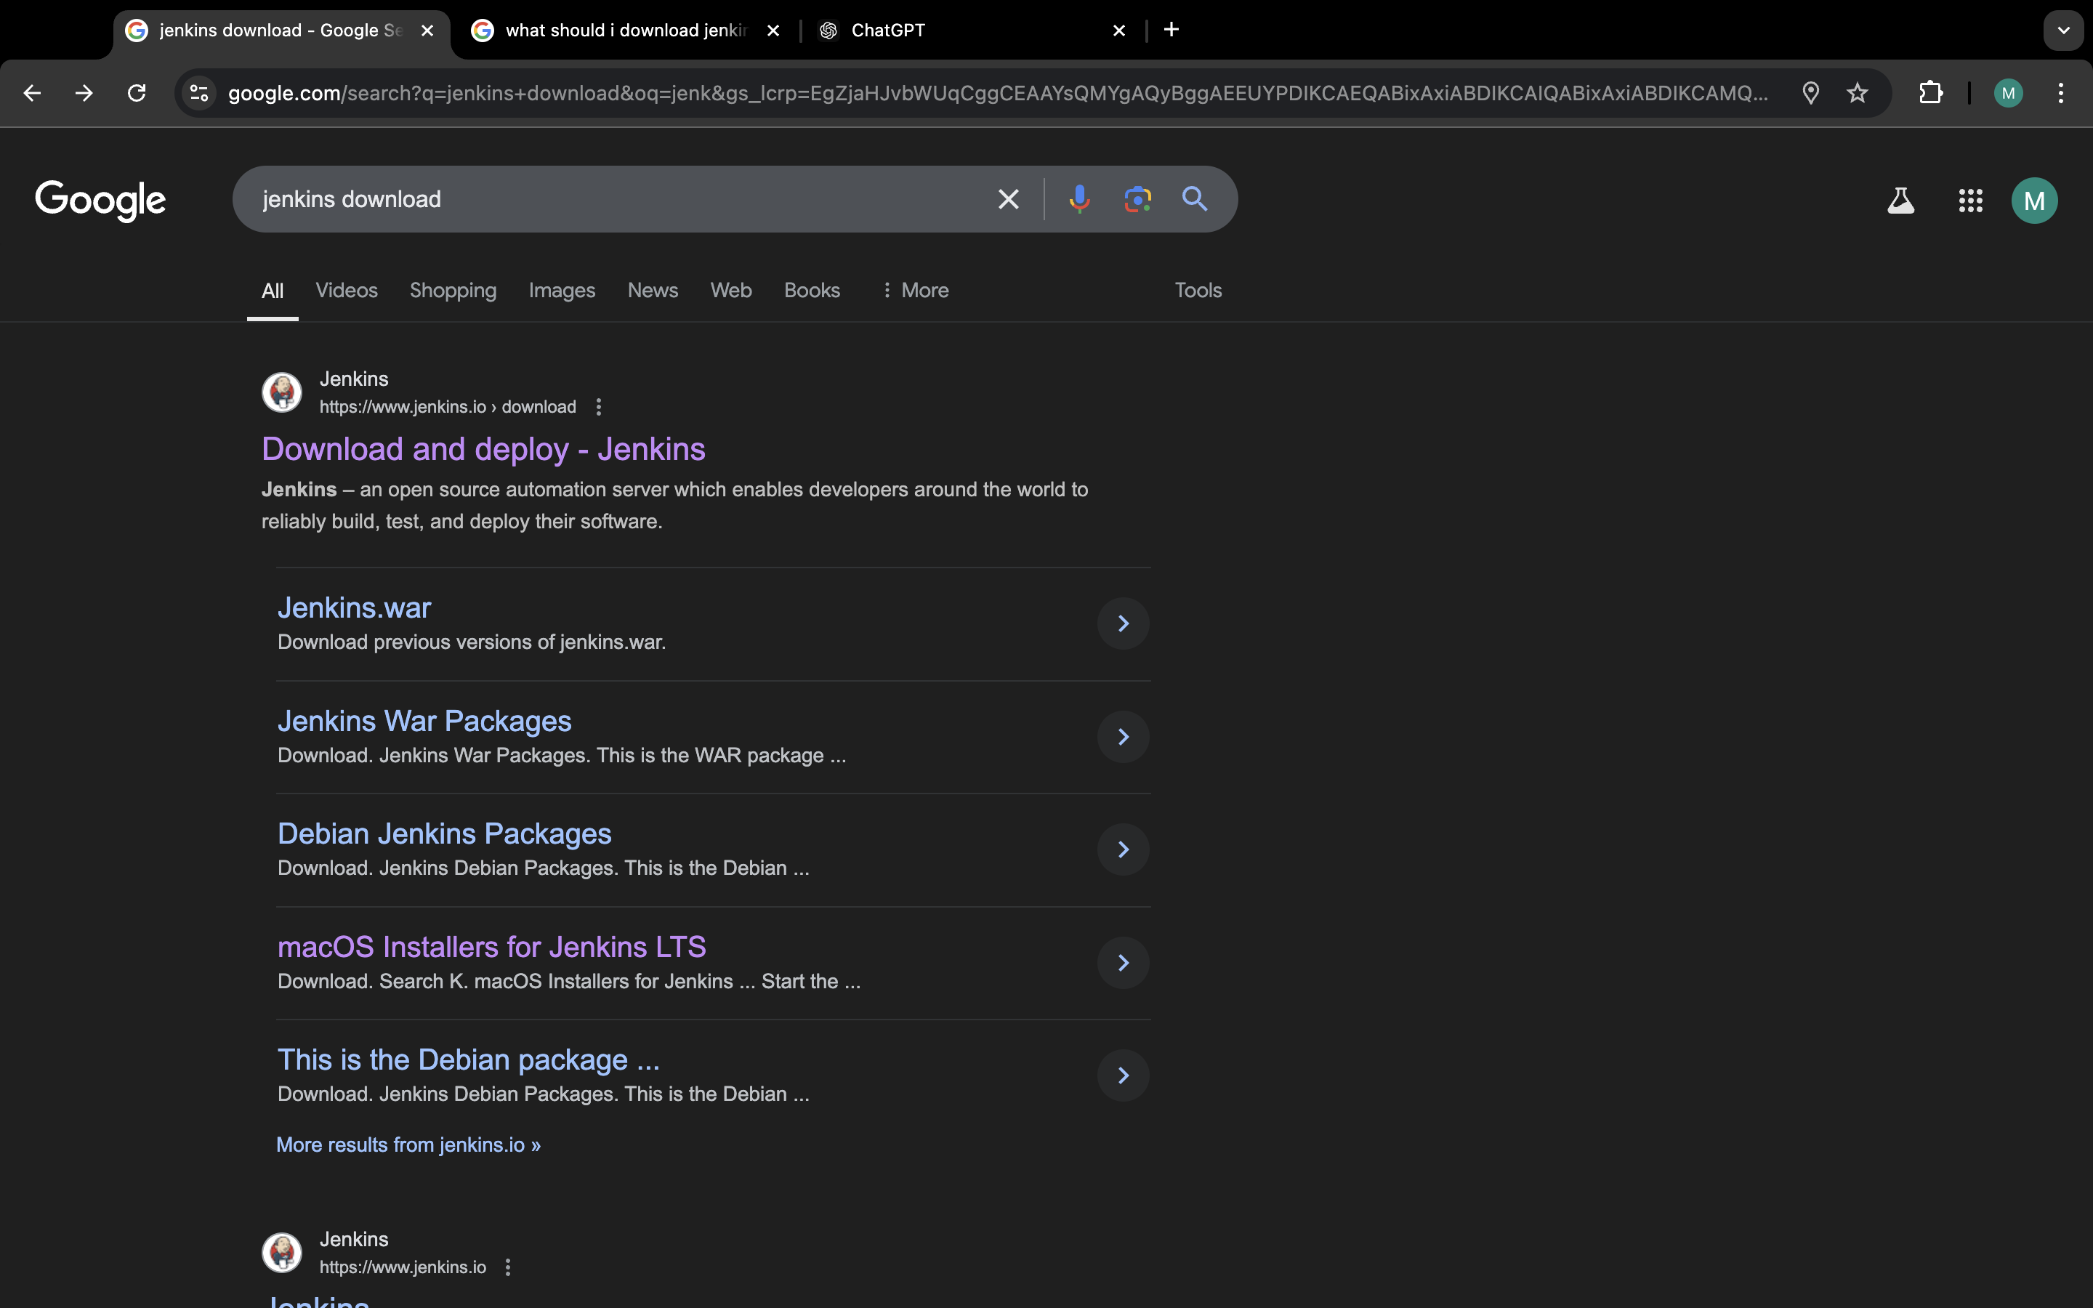

**JENKINS INSTALLATION**

**2) Open the terminal and run the following commands**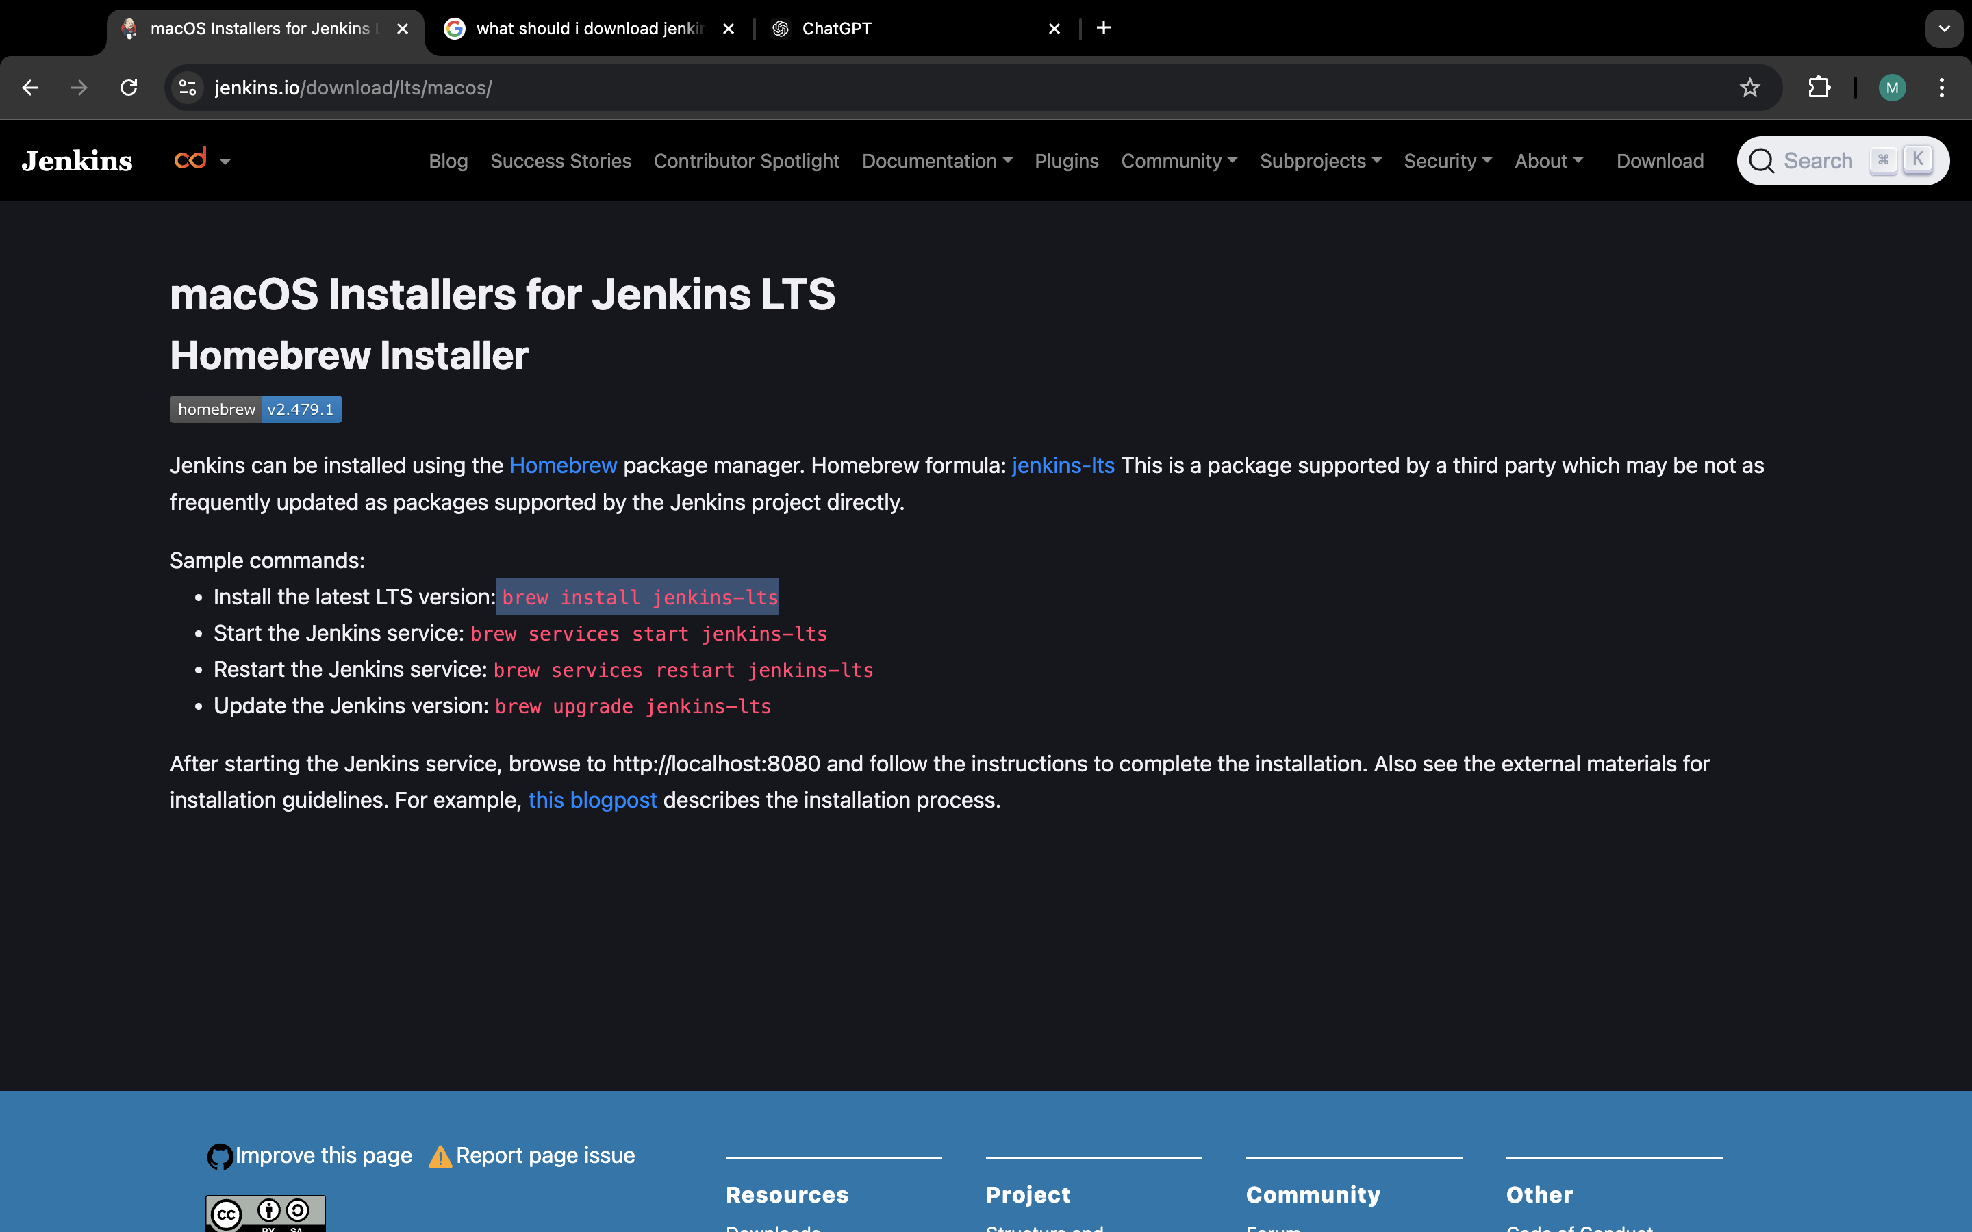

**3) After installing you can run brew services start jenkins-lts command to start the jenkins**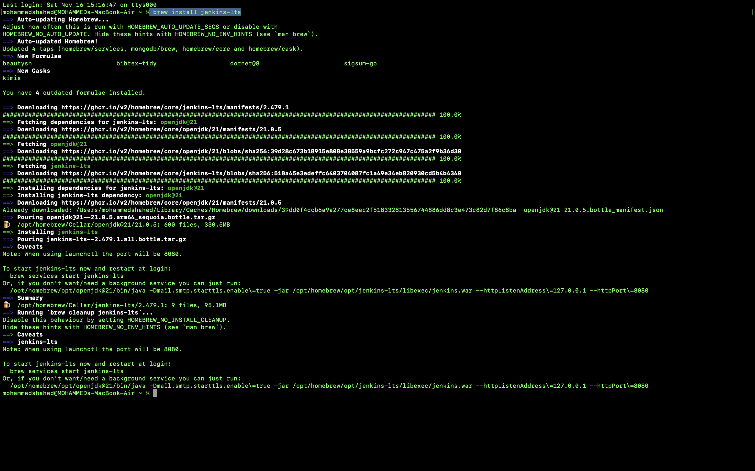

**4) Your Jenkins Installation is done now open the localhost:8080 unlock your jenkins by opening the directory**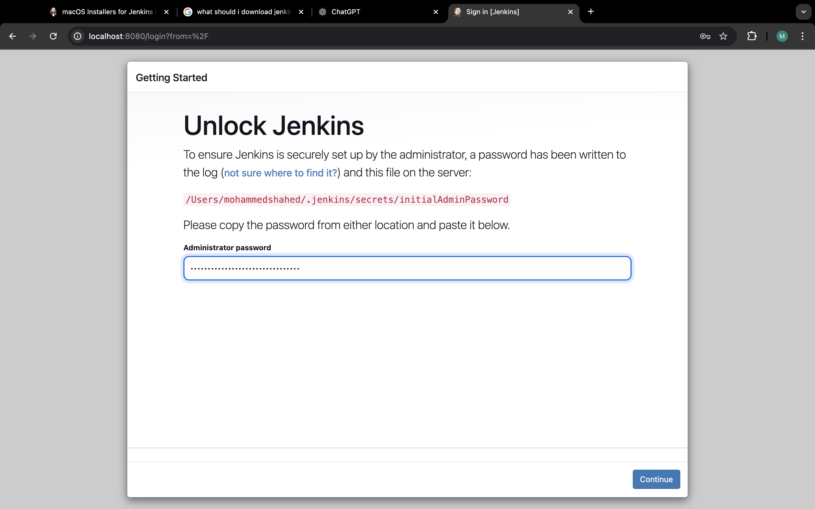

**5) Gettiing Started:  
 Wait till all the features are completed.**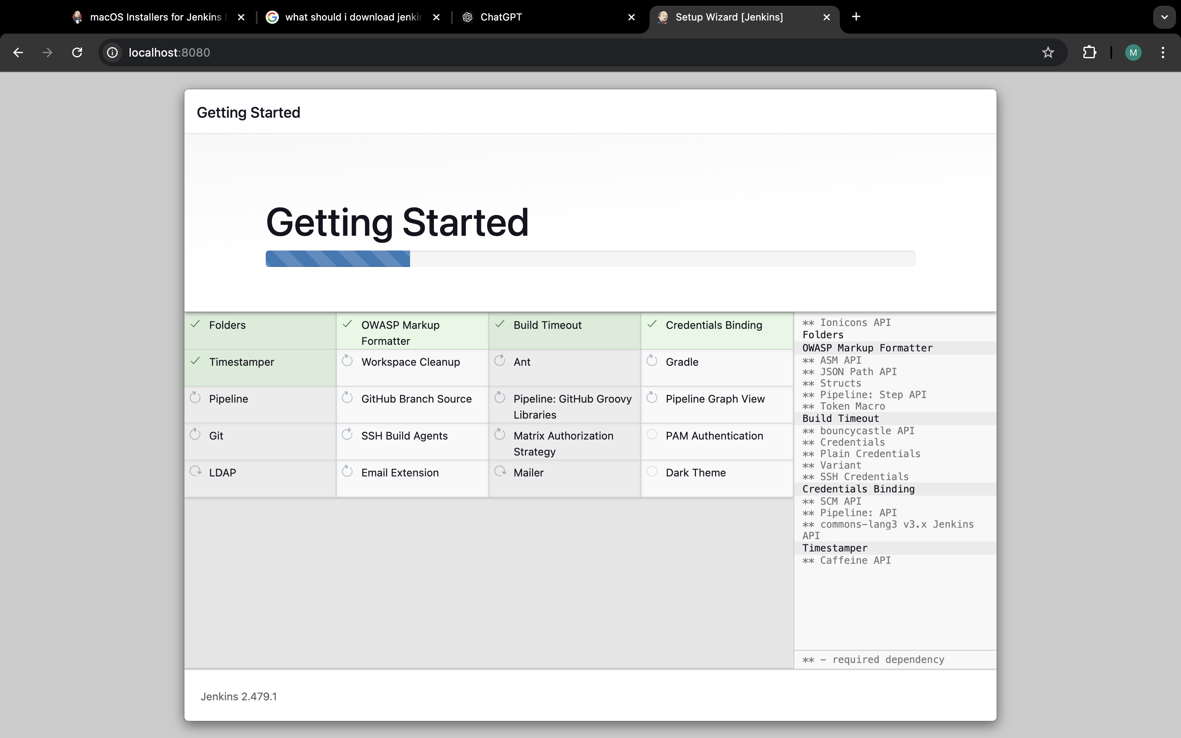

**6) Now sign in to the jenkins with your username and password**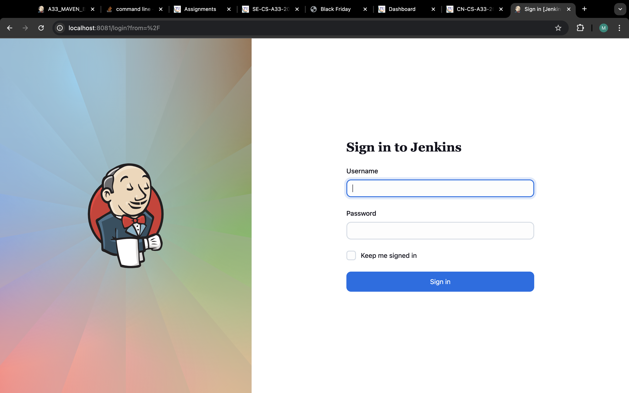

**7) Dashboard of Jenkins**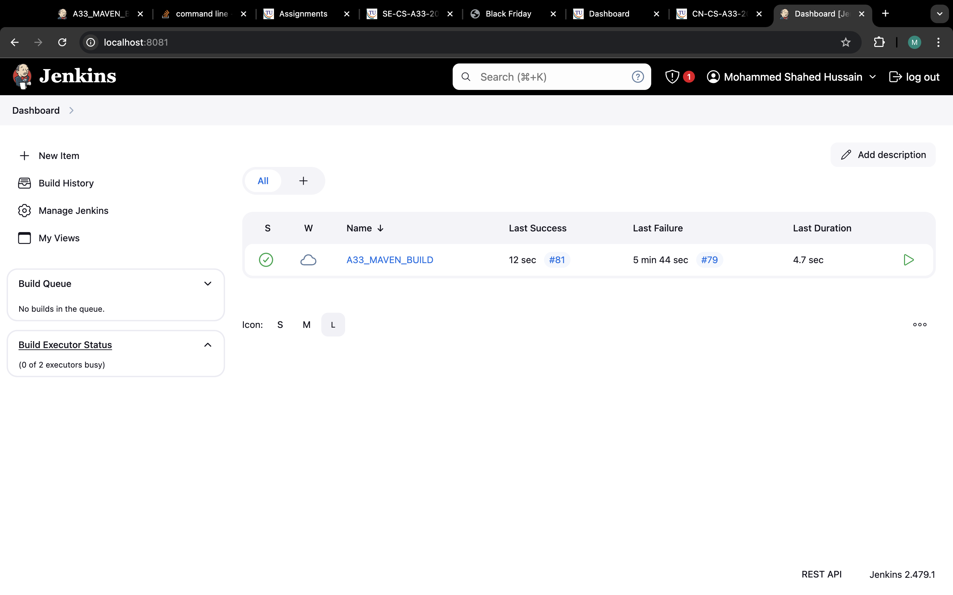

**8) Go to Mange Jenkins:**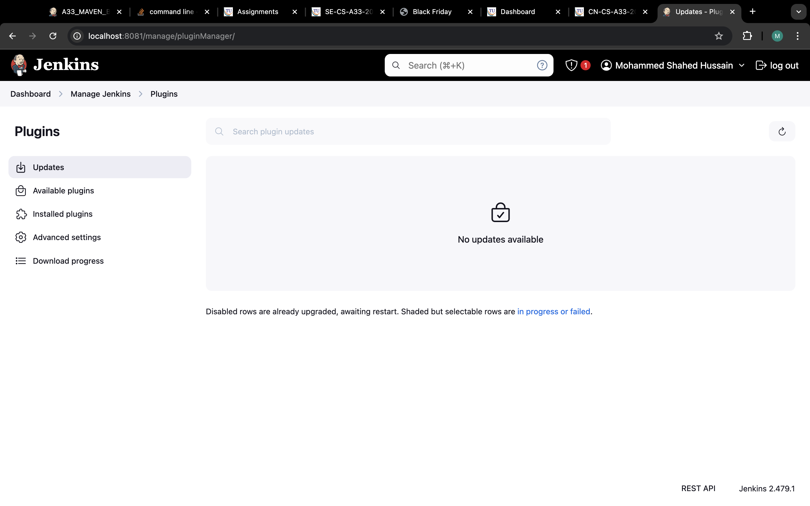

**9) Go to available plugins and install all the needed plugins :**

